**Employee Recruitment System**



Index

|  |  |  |
| --- | --- | --- |
| Sr. No | Content | Page No |
| 1 | Introduction | 3 |
| 2 | Functional Requirement | 4 |
| 3 | ER Diagram | 5 |
| 4 | Database Tables | 6 |
| 5 | Data Definition Language | 15 |
| 6 | Data Manipulation Language | 23 |
| 7 | Project Links | 45 |
| 8 | Bibliography | 46 |

Introduction

A recruitment management system (RMS) is a set of tools designed to manage the recruiting process. It may be the most important core human resources (HR) system. Recruiting is competitive, especially for candidates with high-demand technical skills, and it is driving interest in sophisticated recruiting systems. These systems are being designed to improve the efficiency of recruiters as well as job seekers.

Recruitment process is a process of identifying the job vacancies, analyzing the job requirements, reviewing applications, screening, shortlisting and selecting the right candidate.

This employee recruitment system makes it possible to store the details about staffing requirements,

candidate’s personal details, academics and work experience details, their interview tracking and the final result including the in-house assignment to the project.

There are two users employee and candidate. Employee either being from HR department or from the interviewer panel.

Employee can view the candidate profile, filter the candidate as per the requirement, they have authority to update requirement statistics, they can view/give feedback,view the previous company’s records and documents, make the project assignment once the candidate is selected.Candidate can apply for the respective desired job as per the vacancy, Candidate can update profile, Upload the resume, other documents,check for the vacancies.

An RMS also provides all the information the hiring manager needs to make hiring decisions. This includes the candidate's resume, notes from the interview process, additional documents and information provided by the candidate, pre-hire assessments, and comparison between other

candidates who have applied.

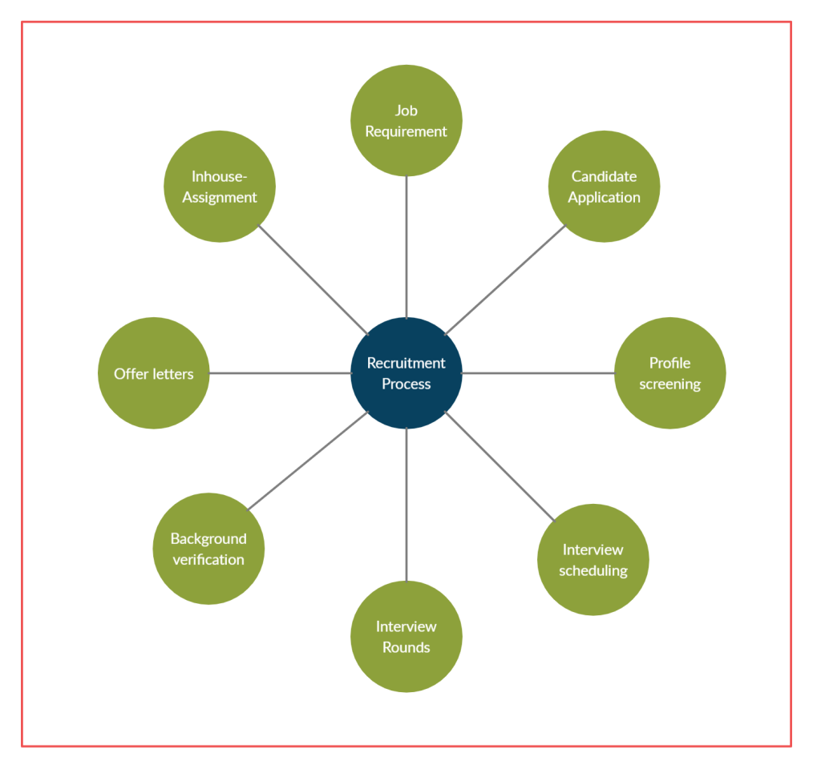

Functional Requirements

Employee Recruitment System:

Candidate:

* Candidate can register into system.
* Candidate can insert the personal information
* Candidate can view job requirements.
* Candidate can apply for the job.
* Candidate can upload resume, other documents.
* Candidate can update their profile.
* Candidate can see the interview details

Employee:

* Employee can login into the system
* Employee can create a job requirement
* Employee can view the candidate’s details
* Employee can add new job location
* Employee can schedule the interview with the candidate
* Update the status of different rounds and give feedback
* Employee can see the interview journey of the candidate
* Assign the hired candidate to the project
* Reject a candidate
* Update the active/inactive status of the candidate, interview, job opening

ER Diagram

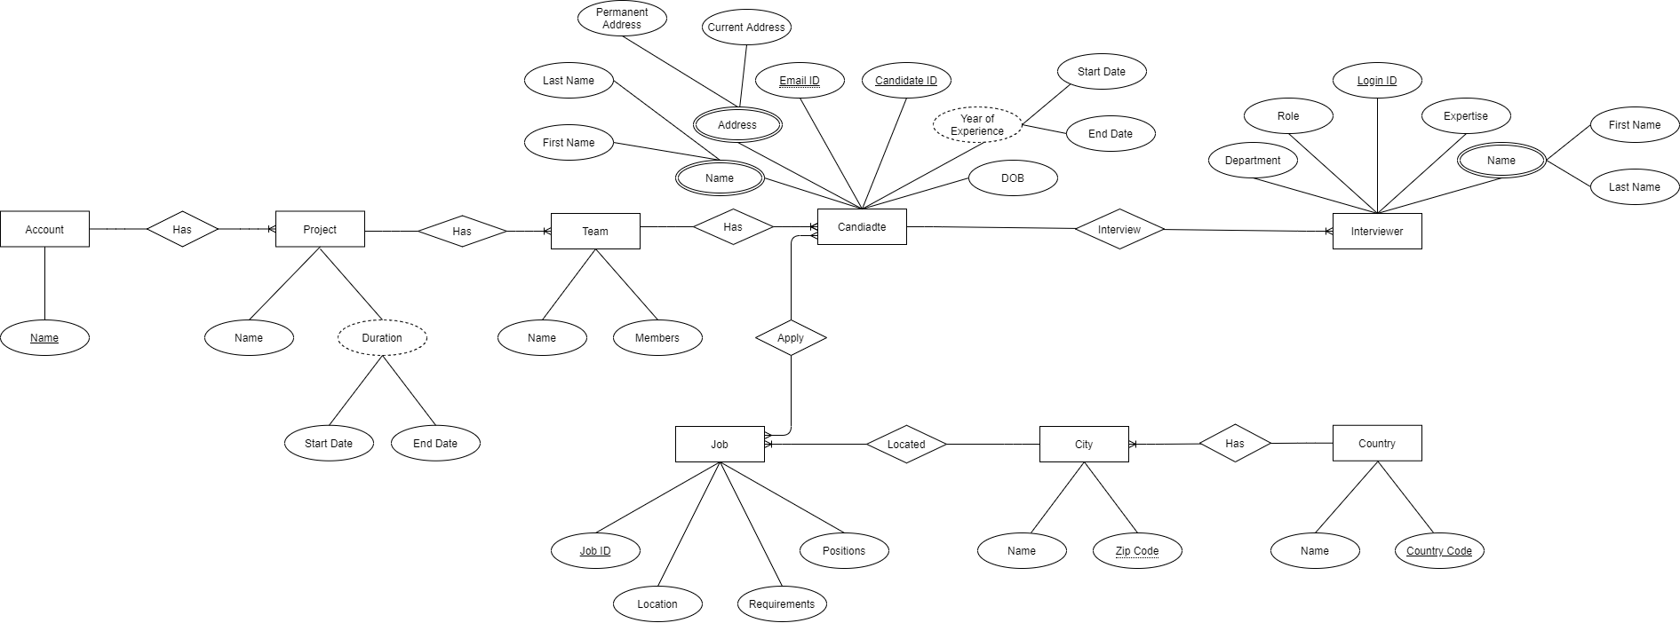

Database Tables

|  |  |  |  |
| --- | --- | --- | --- |
| Assignment | | | |
| Field Name | Data Type | Key/ Constraint | Description |
| Assignment ID | int | PK | Candidate Assignment Id |
| Candidate ID | int | FK | Candidate ID |
| Reporting Manager | varchar |  | Candidate reporting manager ID |
| Team ID | int | FK | Candidate assigned team ID |
| Assignment Start Date | date |  | Candidate assignment Start Date |
| Assignment End Date | date |  | Candidate assignment End Date |

|  |  |  |  |
| --- | --- | --- | --- |
| Account Details | | | |
| Field Name | Data Type | Key/ constraint | Description |
| Account ID | int | PK | Account ID |
| Name | varchar |  | Account Name |

|  |  |  |  |
| --- | --- | --- | --- |
| Login | | | |
| Field Name | Data Type | Key/ Constraint | Description |
| email | varchar | PK | user email id |
| password | varchar |  | account password |
| user Type | enum |  | user type (candidate/employee) |
| Is\_active | boolean |  | Is user account active? |
| Last\_updated\_on | timestamp |  | Record last updated timestamp |

|  |  |  |  |
| --- | --- | --- | --- |
| Candidate\_Personal\_Details | | | |
| Field Name | Data Type | Key/ Constraint | Description |
| Candidate ID | int | PK | Candidate ID |
| First Name | varchar |  | Candidate First Name |
| Last Name | varchar |  | Candidate last name |
| Gender | Enum |  | Gender |
| email | varchar | FK , Unique | Candidate registered email id |
| country code | varchar |  | Candidate country code |
| contact no | int |  | Candidate contact Number |
| permenent\_address | varchar |  | Candidate permanent Address |
| temp\_address | varchar |  | Candidate temporary Address |
| is\_address\_same | enum |  | Are both Addresses same? Yes or No |
| highest\_education | enum |  | Candidate highest education |
| experience | varchar |  | Candidate work experience |
| Resume | varchar |  | Candidate resume path |
| Internl\_Status | int | fk | Candidate status inside company |
| Last\_updated\_on | timestamp |  | Record last updated timestamp |

|  |  |  |  |
| --- | --- | --- | --- |
| Can\_Academic\_Details | | | |
| Field Name | Data Type | Key/Constraint | Description |
| academic\_record\_id | int | PK | academic record's id |
| can\_id | int | FK | candidate id |
| academics | varchar |  | candidate academics Degree/Diploma |
| specification | varchar |  | Degree specification |
| board\_university | varchar |  | university/ college/ board name |
| passing\_year | int |  | passing year |
| gap | enum |  | is there any gap? |
| gap reason | varchar |  | if yes then reason |
| grades | varchar |  | academic grades |
| academic\_doc\_name | varchar |  | academic document |
| academic\_doc\_path | varchar |  | document path |

|  |  |  |  |
| --- | --- | --- | --- |
| City | | | |
| Field Name | Data Type | Key/Constraint | Description |
| ID | int | PK | City id |
| Name | varchar |  | City Name |
| Country abbreviation | varchar | FK | County abbreviation (IN,CA,US) |

|  |  |  |  |
| --- | --- | --- | --- |
| Company References | | | |
| Field Name | Data Type | Key/ constraint | Description |
| reference\_id | int | PK | reference ID |
| Exp\_id | int | FK | Candidate experience id |
| referenceOne\_fname | varchar |  | Reference 1 first name |
| referenceOne\_lname | int |  | Reference 1 last name |
| referenceOne\_email | varchar |  | Reference 1 email |
| referenceOne\_contact | varchar |  | Reference 1 country code |
| referenceOne\_countryCode | varchar |  | Reference 1 contact number |
| referenceOne\_realtion | varchar |  | Reference 1 relation with candidate |
| referenceTwo\_fname | varchar |  | Reference 2 first name |
| referenceTwo\_lname | int |  | Reference 2 last name |
| referenceTwo\_email | varchar |  | Reference 2 email |
| referenceTwo\_contact | varchar |  | Reference 2 country code |
| referenceTwo\_countryCode | varchar |  | Reference 2 contact number |
| referenceTwo\_realtion | varchar |  | Reference 2 relation with candidate |

|  |  |  |  |
| --- | --- | --- | --- |
| Country | | | |
| Field Name | Data Type | Key/constraint | Description |
| Country Abbreviation | varchar | Pk | Country abbreviation(IN,CA) |
| Name | varchar |  | Country Name |

|  |  |  |  |
| --- | --- | --- | --- |
| Employee\_details | | | |
| Field Name | Data Type | Key/ Constraint | Description |
| emp\_id | int | PK | employee id |
| can\_id | int | FK | candidate id |
| department | varchar |  | candidate's department |
| designation | varchar |  | candidate's designation |
| salary PA | varchar |  | salary per annum |
| work\_email | varchar | unique | employee's email id |

|  |  |  |  |
| --- | --- | --- | --- |
| Experience Details | | | |
| Field Name | Data Type | Key/Constraint | Description |
| Exp\_id | int | PK | Experience ID |
| Can\_id | int | FK | Candidate ID |
| Company Name | varchar |  | Company Name |
| Start Date | date |  | Experience Start Date |
| End Date | date |  | Experience End Date |

|  |  |  |  |
| --- | --- | --- | --- |
| Internal\_status | | | |
| Field Name | Data Type | Key/ constraint | Description |
| status\_id | int | PK | Status Id |
| status | varchar |  | Company internal status for candidate |
| description | varchar |  | status description |

|  |  |  |  |
| --- | --- | --- | --- |
| Interview Journey | | | |
| Field Name | Data Type | Key/Constraint | Description |
| Journey\_ID | int | PK | journey id |
| interview\_ID | int | FK | interview schedule id |
| Round ID | int | FK | interview round id |
| Interview\_status | enum |  | interview status |
| Feedback | varchar |  | interview feedback |
| Result\_date | current date |  | interview result date |

|  |  |  |  |
| --- | --- | --- | --- |
| Interview Panel Details | | | |
| Field Name | Data Type | Key/Constraint | Description |
| interviewer\_id | int | PK | Interviewer ID |
| emp\_id | int | FK | Employee ID |
| Journey ID | int | FK | Interview Journey ID |
| Experties | varchar |  | Interview Panel Expertise |
| Level | enum |  | Interview Level |

|  |  |  |  |
| --- | --- | --- | --- |
| Interview Round Details | | | |
| Field Name | Data Type | Key/ Constraint | Description |
| Round\_ID | int | PK | Round ID |
| Round\_Name | varchar |  | Round Name |
| Description | varchar |  | Round Description |
| Priority | varchar |  | Round Priority |

|  |  |  |  |
| --- | --- | --- | --- |
| Interview Schedule | | | |
| Field Name | Data Type | Key/Constraint | Description |
| interview\_id | int | PK | interview Id |
| Application\_id | int | FK | Application ID |
| interview\_Date | date |  | Interview date |
| Time Slot | varchar |  | interview time slot |
| Time Zone | varchar |  | interview conducting time zone |
| Interview\_type | enum |  | Interview type |
| interview\_link | varchar |  | Interview Link |
| poc\_id | int | FK | point of contact id |
| Is\_rescheduled | Enum |  | Is interview rescheduled? |
| Rescheduling\_reason | Varchar |  | Reason to reschedule the interview |
| Last\_updated\_on | Timestamp |  | Record last updated on |

|  |  |  |  |
| --- | --- | --- | --- |
| Job Application | | | |
| Field Name | Data Type | Key/ Constraint | Description |
| Application ID | int | PK | Application ID |
| Candidate ID | int | FK | Candidate ID |
| Job ID | int | FK | Job ID |

|  |  |  |  |
| --- | --- | --- | --- |
| Job Openings | | | |
| Field Name | Data Type | Key/ Constraint | Description |
| Job\_ID | int | PK | Job id |
| Title | varchar |  | Job title |
| Description | varchar |  | Job description |
| requiredExperince | varchar |  | required experience for job |
| Skills | varchar |  | required skills |
| openings | int |  | no of job openings |
| rounds | int |  | no of interview rounds |
| location | int | FK | job location |
| Is\_active | Boolean |  | Is job opening active |
| Inactive reason | Varchar |  | Job inactive reason |
| Last\_updated\_on | Timestamp |  | Record last updated timestamp |

|  |  |  |  |
| --- | --- | --- | --- |
| Location | | | |
| Field Name | Data Type | Key/Constraint | Description |
| id | int | PK | Location ID |
| address | varchar |  | Location Address |
| zipcode | int |  | City Zip Code |
| city\_id | int | FK | City ID |

|  |  |  |  |
| --- | --- | --- | --- |
| Project | | | |
| Field Name | Data Type | Key/Constraint | Description |
| Project \_ID | int | PK | Project ID |
| project\_name | varchar |  | Project Name |
| Account\_ID | int | FK | Project related account id |
| start\_date | date |  | Project start date |
| end\_date | date |  | Project end date |
| duration | int |  | project duration in months |

|  |  |  |  |
| --- | --- | --- | --- |
| Rejected\_Can\_Details | | | |
| Field Name | Data Type | Key/ Constraint | Description |
| rejected\_id | int | PK | rejected id |
| Journey ID | int | FK | journey id |
| blocked\_till\_date | date |  | candidate rejected till date |

|  |  |  |  |
| --- | --- | --- | --- |
| Selected\_Can\_Details | | | |
| Field Name | Data Type | Key/Constraint | Description |
| selected\_id | int | PK | selected id |
| Journey ID | int | FK | Journey ID |
| Hire Date | date |  | Candidate hired date |
| Is Offer Accepted | enum |  | Has candidate accepted the offer |
| Curr\_date | date |  | current date |

|  |  |  |  |
| --- | --- | --- | --- |
| Team Details | | | |
| Field Name | Data Type | Key/Constraint | Description |
| Team\_id | int | PK | Team ID |
| team\_name | varchar |  | Team name |
| Project ID | int | Fk | Team under project |

|  |  |  |  |
| --- | --- | --- | --- |
| Test\_details | | | |
| Field Name | Data Type | Key/Constraint | Description |
| test\_project\_id | int | PK | test project id |
| interview\_id | int | FK | interview id |
| project\_description | varchar |  | test project summary |
| Test\_detail\_doc | varchar |  | test document path |
| deadline | date |  | test deadline |
| submitted\_Date | date |  | test submitted date |

|  |  |  |  |
| --- | --- | --- | --- |
| Work Experience Documents | | | |
| Field Name | Data Type | Key/Constraint | Description |
| doc\_id | int | PK | Document ID |
| exp\_id | int | FK | Experience ID |
| Document\_Name | varchar |  | Document Name |
| Document\_path | varchar |  | Document Path |

**Schema Diagram**

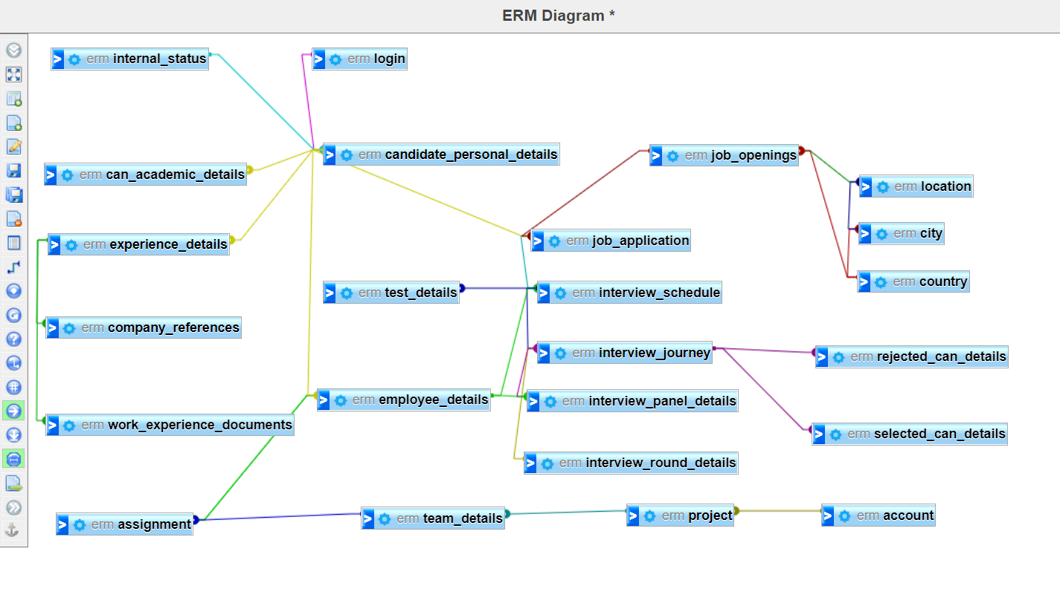

Data Definition Language

**Create table queries**

Create table country (country\_abbrivation varchar(5), country\_name varchar(10), primary key (country\_abbrivation))

Create table city (id int not null AUTO\_INCREMENT, city\_name varchar(10), country\_abbrivation varchar(5), primary key (id), foreign kay (country\_abbrivation) references country(country\_abbrivation))

create table location (id int null AUTO\_INCREMENT,address varchar(50), zip\_code int, city\_id int, primary key (id), FOREIGN key (city\_id) REFERENCES city(id))

create table job\_openings (job\_id int not null AUTO\_INCREMENT, title varchar(20),description varchar(200),skills varchar(100),location int,country varchar(5),openings int,rounds int,requiredExperience float,FOREIGN key (location) REFERENCES location(id), FOREIGN KEY(country) REFERENCES country(country\_abbrivation), CONSTRAINT job\_id PRIMARY key (job\_id) )

create table login (email varchar(100) not null, password varchar(10), PRIMARY key (email))

create table internalStatus(status\_id int not null AUTO\_INCREMENT,status varchar(10),description varchar(200),primary key (status\_id) )

create table candidate\_personal\_details(can\_id int not null AUTO\_INCREMENT, firstName varchar(30), lastName varchar(30),gender enum("Male","Female","Other") not null, email varchar(50) not null,country\_code varchar(5), contactNumber int,permenent\_address varchar(200), temp\_address varchar(200), is\_address\_same boolean, experience float,resume varchar(2000),internalStatus int, primary key (can\_id), FOREIGN key (email) REFERENCES login(email) , FOREIGN key (internalStatus) REFERENCES internal\_status(status\_id))

create table experience\_details(exp\_id int not null AUTO\_INCREMENT,can\_id int not null,company\_name varchar(100), start\_date date,end\_date date, PRIMARY key (exp\_id),FOREIGN key (can\_id) REFERENCES candidate\_personal\_details(can\_id))

create table work\_experience\_documents(doc\_id int not null AUTO\_INCREMENT, exp\_id int not null, releaving\_ltr varchar(2000) default null, experience\_ltr varchar(2000) default null,PRIMARY KEY(doc\_id), FOREIGN key (exp\_id) REFERENCES experience\_details (exp\_id))

create table company\_references (reference\_id int not null AUTO\_INCREMENT, exp\_id int not null, referenceOne\_Fname varchar(50) not null, referenceOne\_Lname varchar(50) not null , referenceOne\_email varchar (100) not null, referenceOne\_contact bigint, referenceOne\_designation varchar(50), referenceOne\_realtion varchar(50) not null ,referenceTwo\_Fname varchar(50) not null, referenceTwo\_Lname varchar(50) not null , referenceTwo\_email varchar (100) not null, referenceTwo\_contact bigint , referenceTwo\_designation varchar(50), referenceTwo\_realtion varchar(50) not null, primary key(reference\_id),FOREIGN key (exp\_id) REFERENCES experience\_details (exp\_id))

create table interview\_panel\_details(interviewer\_id int not null AUTO\_INCREMENT,interviewer\_Name varchar(50) not null,department\_name varchar(50),interviewer\_email varchar(50) not null,expertise varchar(100),experience float, role varchar(30), PRIMARY key(interviewer\_id))

create table interview\_round\_details (round\_id int not null AUTO\_INCREMENT, round\_name varchar(30) not null, description varchar(200), priority varchar(10) not null, primary key (round\_id))

create table job\_application (application\_id int not null AUTO\_INCREMENT, can\_id int not null, job\_id int not null, PRIMARY key (application\_id), FOREIGN key (can\_id) REFERENCES candidate\_personal\_details (can\_id), FOREIGN KEY (job\_id) REFERENCES job\_openings (job\_id))

create table employee\_details(work\_email varchar(50) not null,can\_id int not null, designation varchar(30), reporting\_manager int not null,salary float not null, department varchar(30),FOREIGN key (can\_id) REFERENCES candidate\_personal\_details(can\_id))

create table interview\_schedule(interview\_id int not null AUTO\_INCREMENT,application\_id int not null, interview\_date date not null, time\_slot varchar(30) default null, time\_zone varchar(20) default null,poc\_id int not null , interview\_type enum ("Online\_Test","Test\_Project","In Person Interview","video conferencing") not null, interview\_link varchar(1000), primary key(interview\_id), FOREIGN key (poc\_id) REFERENCES employee\_details(emp\_id))

create table test\_details (project\_id int not null AUTO\_INCREMENT, project\_description varchar(1000),test\_detail\_doc varchar(200),deadline date, submiited\_date date,interview\_id int not null, PRIMARY key (project\_id), FOREIGN key (interview\_id) REFERENCES interview\_schedule(interview\_id) )

create table interview\_journey(journey\_id int not null AUTO\_INCREMENT,interview\_id int not null, round\_id int not null, interviewer\_id int, interview\_status enum("Selected", "Rejected", "Awaiting"), feedback varchar(500), PRIMARY key (journey\_id), FOREIGN key (interview\_id) REFERENCES interview\_schedule (interview\_id), FOREIGN key (round\_id) REFERENCES interview\_round\_details(round\_id),FOREIGN key (interviewer\_id) REFERENCES interview\_panel\_details (interviewer\_id) )

create table rejected\_can\_details (rejected\_id int not null AUTO\_INCREMENT, journey\_id int not null,blocked\_till\_date date not null, PRIMARY key(rejected\_id),FOREIGN key (journey\_id) REFERENCES interview\_journey(journey\_id))

create table selected\_can\_details (selected\_id int not null AUTO\_INCREMENT, journey\_id int not null,hire\_date date, is\_offer\_accepted enum("Y","N"), PRIMARY key(selected\_id), FOREIGN key (journey\_id) REFERENCES interview\_journey(journey\_id))

create table account(account\_id int not null AUTO\_INCREMENT, account\_name varchar(20), PRIMARY key (account\_id))

create table project(project\_id int not null AUTO\_INCREMENT, project\_name varchar(50), start\_date date,end\_date date, duration float,account\_id int ,PRIMARY key(project\_id),FOREIGN key(account\_id) REFERENCES account(account\_id))

create table team\_details(team\_id int not null AUTO\_INCREMENT, team\_name varchar(30), project\_id int not null,PRIMARY key(team\_id), FOREIGN key(project\_id) REFERENCES project(project\_id))

create table assignment(assignment\_id int not null AUTO\_INCREMENT,emp\_id int not null, reporting\_manager int not null, team\_id int not null, assignment\_start\_date date not null, assignment\_end\_Date date default null, PRIMARY key(assignment\_id), FOREIGN key(emp\_id) REFERENCES employee\_details(emp\_id), FOREIGN key(reporting\_manager) REFERENCES employee\_details(emp\_id), FOREIGN key(team\_id) REFERENCES team\_details(team\_id))

create table can\_academic\_details(academic\_record\_id int not null AUTO\_INCREMENT, can\_id int not null, academics varchar(30),specification varchar(30),board\_university varchar(100) not null ,passing\_year int, gap enum("Y","N") not null, gap\_reason varchar(2000),grades varchar(10),academic\_doc\_name varchar(100),academic\_doc\_path varchar(500),PRIMARY key(academic\_record\_id),FOREIGN key(can\_id) REFERENCES candidate\_personal\_details(can\_id))

**Alter queries**

alter table location modify column zip\_code varchar(10)

Alter table job\_openings modify column requiredExperience varchar(5)

alter table login add column userType enum("Candidate","Employee")

rename table `internalstatus` to `internal\_status`

ALTER TABLE candidate\_personal\_details AUTO\_INCREMENT = 5000;

ALTER TABLE `candidate\_personal\_details` Alter`internalStatus` INT(11) NOT NULL

alter table candidate\_personal\_details modify column contactNumber bigint

alter table experience\_details alter end\_date set default null

alter table company\_references add column country\_code varchar(5) not null

ALTER TABLE `company\_references` CHANGE `referenceTwo\_realtion` `referenceTwo\_relation` VARCHAR(50)

alter table employee\_details change `salary` `salary PA` varchar(30)

alter table selected\_can\_details add column CURR\_DATE date default CURRENT\_DATE

ALTER TABLE test\_details CHANGE project\_id test\_project\_id INT(11) NOT NULL AUTO\_INCREMENT;

Alter table login add column is\_active boolean not null

**Add any constraint**

ALTER TABLE login ADD CONSTRAINT lengthChk CHECK (char\_length(password) >= 8);

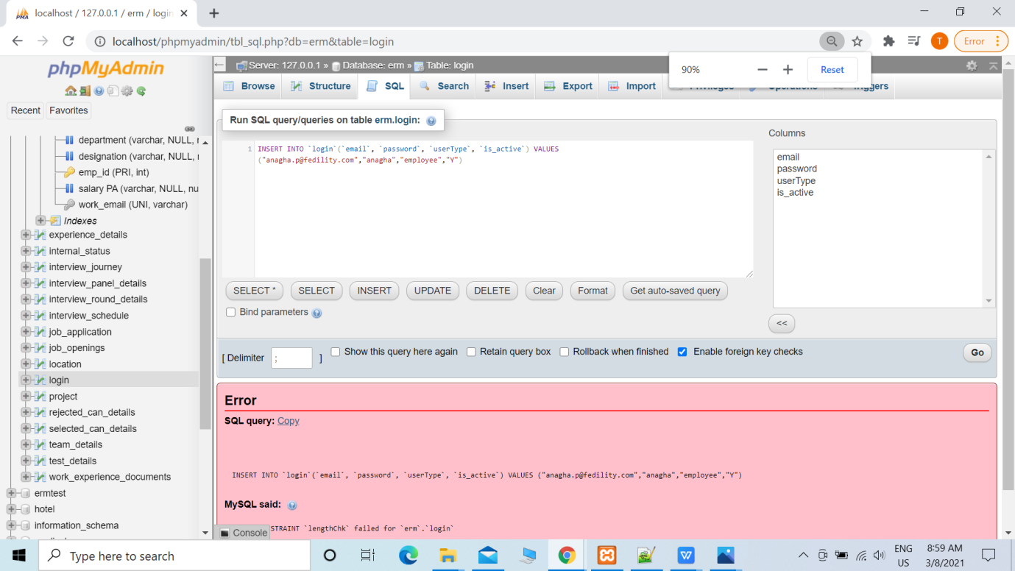

alter table candidate\_personal\_details add CONSTRAINT UNIQUE (email)

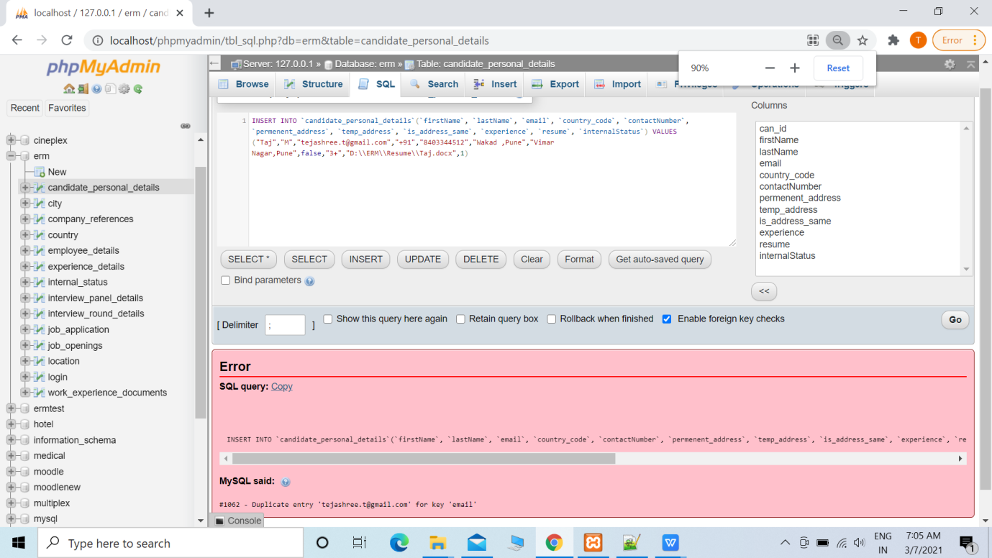

alter table experience\_details add CONSTRAINT end\_date\_greater\_than\_start\_date\_ck CHECK (start\_date < end\_date)

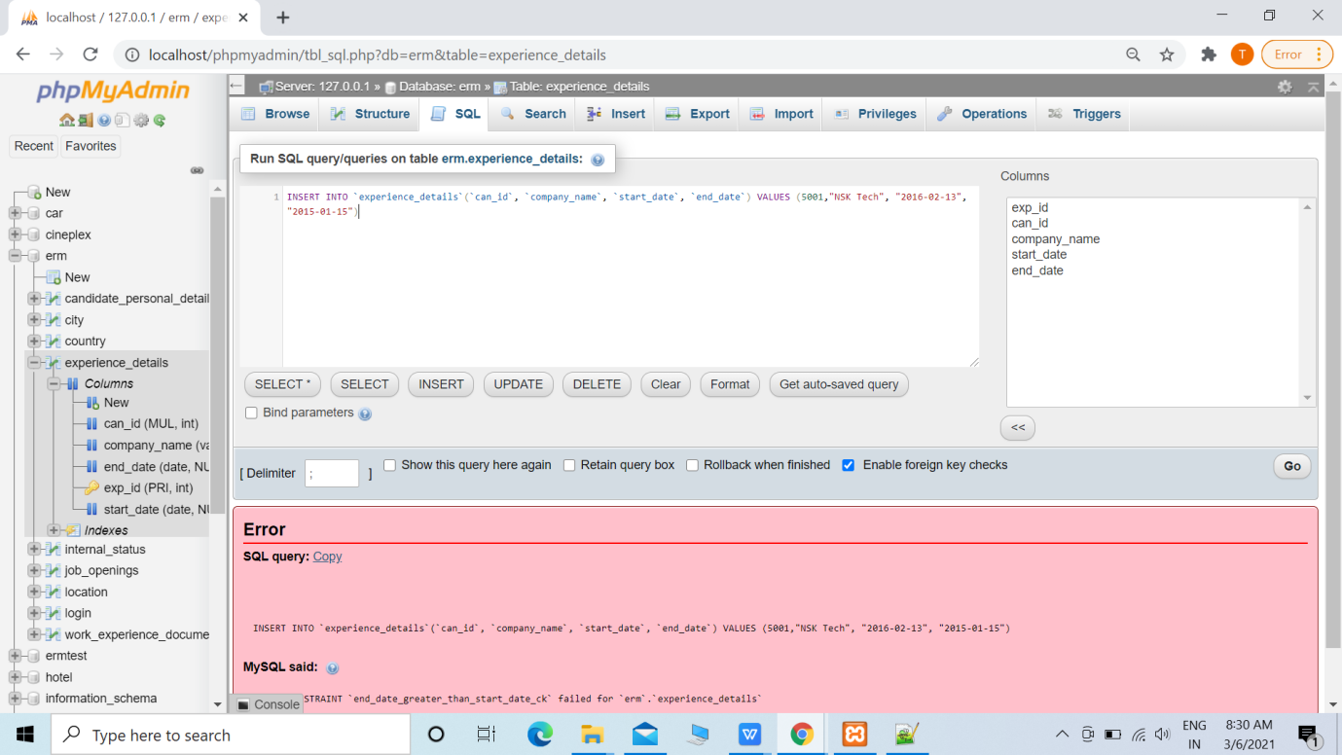

[alter](http://localhost/phpmyadmin/url.php?url=https://dev.mysql.com/doc/refman/5.5/en/alter-table.html" \t "http://localhost/phpmyadmin/mysql_doc) [table](http://localhost/phpmyadmin/url.php?url=https://dev.mysql.com/doc/refman/5.5/en/alter-table.html" \t "http://localhost/phpmyadmin/mysql_doc) test\_details add CONSTRAINT submitted\_date\_is\_less\_or\_equal\_to\_deadline CHECK ( submiited\_date<= deadline)

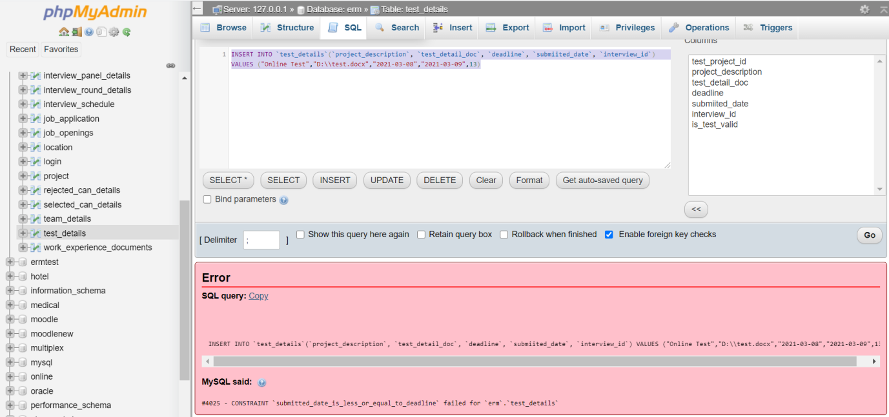

alter table selected\_can\_details add CONSTRAINT hire\_date\_greater\_than\_current\_date CHECK ( hire\_date> CURR\_DATE)

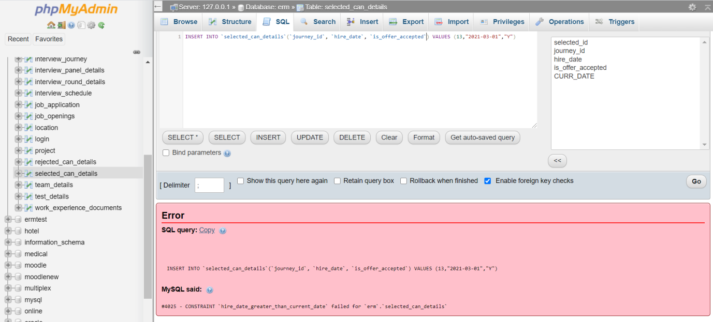

alter table interview\_schedule add CONSTRAINT interview\_date\_not\_in\_past CHECK ( interview\_date> CURR\_DATE)

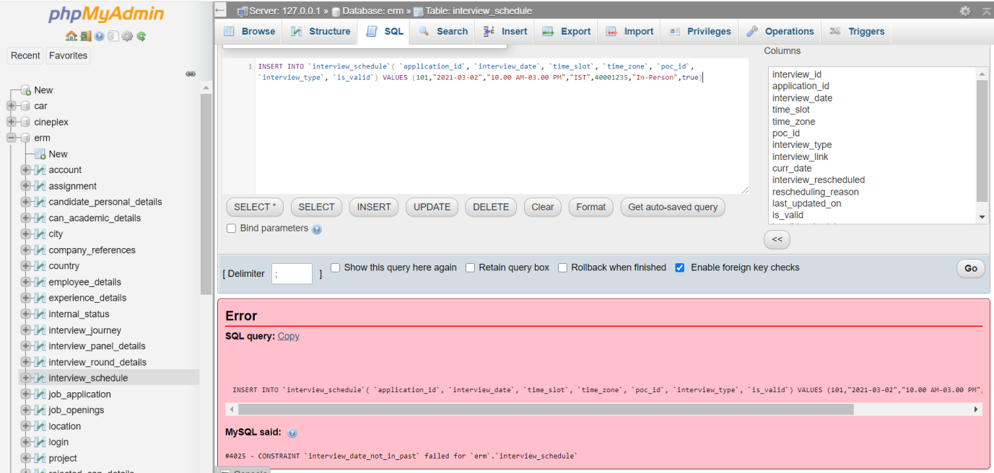

alter table employee\_details add unique (work\_email)

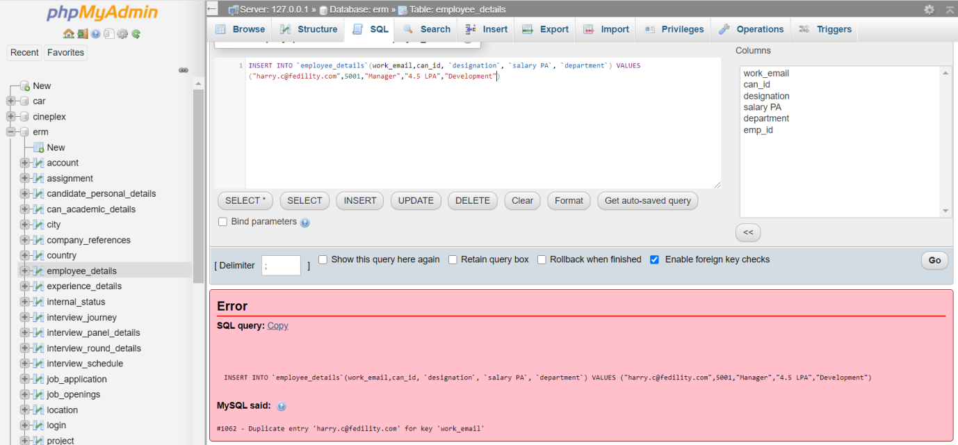

Alter table work\_experience\_documents add constraint unique (document\_path)

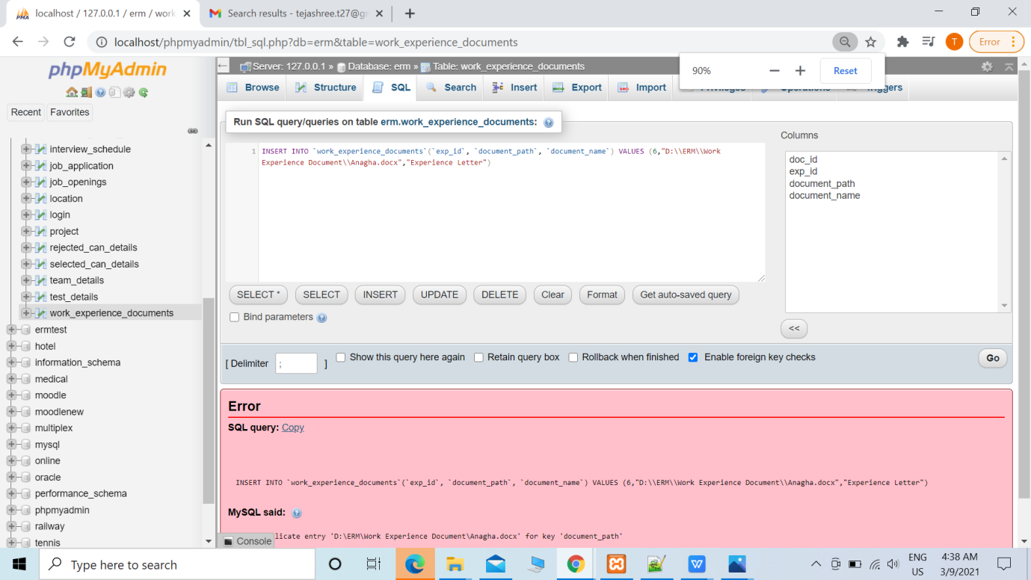

Data Manipulation Language

***Insert queries***

Insert into country (country\_abbrivation,country\_name) values ("FR","France")

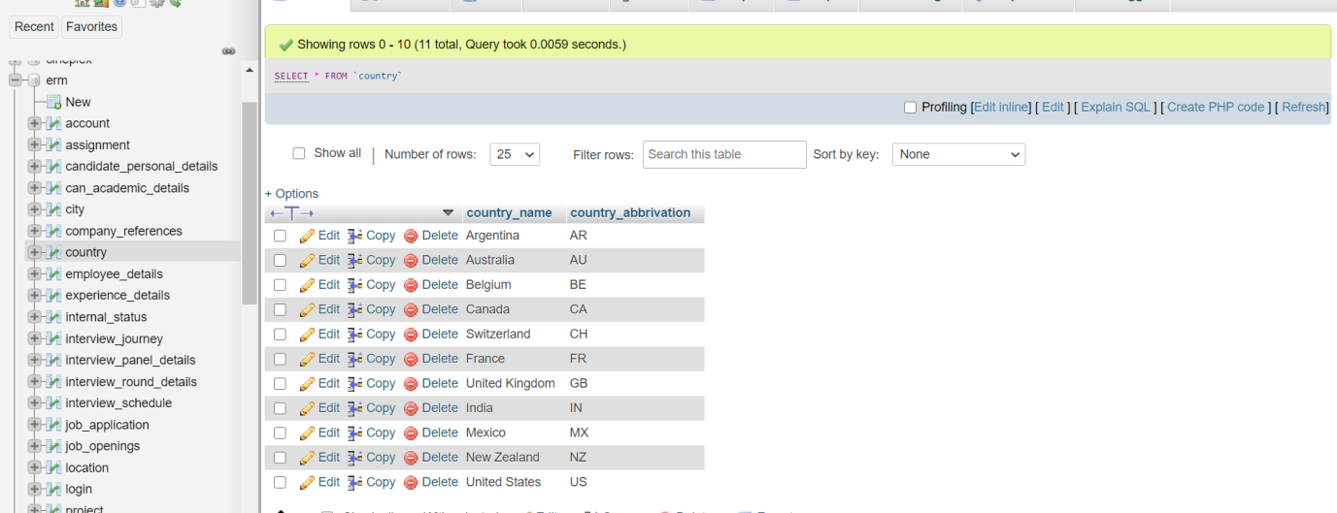

Insert into city (city\_name,country\_abbrivation) values ("Paris", "FR")

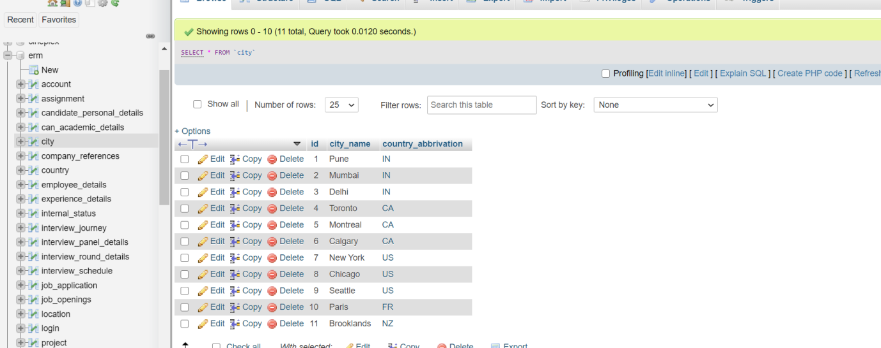

[INSERT](http://localhost/phpmyadmin/url.php?url=https://dev.mysql.com/doc/refman/5.5/en/insert.html" \t "http://localhost/phpmyadmin/mysql_doc) INTO location(`id`, `address`, `zip\_code`, `city\_id`) [VALUES](http://localhost/phpmyadmin/url.php?url=https://dev.mysql.com/doc/refman/5.5/en/miscellaneous-functions.html" \l "function_values" \t "http://localhost/phpmyadmin/mysql_doc) (1,"Phase 1 ,Hinjewadi" , 411057, 1)

INSERT INTO `location`( `address`, `zip\_code`, `city\_id`) VALUES ("Saint-Catherine Street, Montreal","J5C",5)

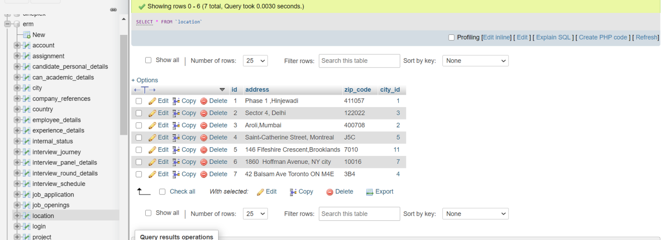

INSERT INTO job\_openings(`job\_id`, `title`, `description`, `skills`, `location`, `country`, `openings`, `rounds`, `requiredExperience`) VALUES (1000, "Test Automation Engineer", "Test Automation engineer with manual testing experience is required", "STLC, Agile,Java, SQL,API,Maven,BDD", 1, "IN", 3,3, "5+" )

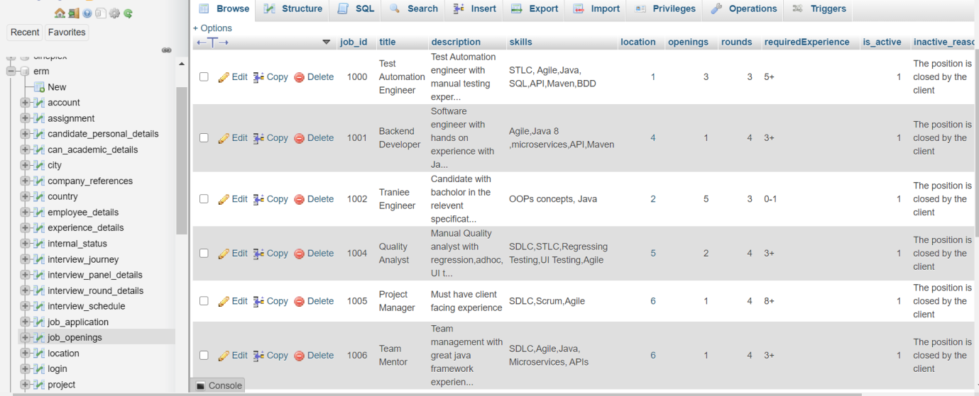

INSERT INTO login(`email`, `password`,userType) VALUES [("tejashree.t@gmail.com","Online@123","Candidate")](mailto:(\"tejashree.t@gmail.com\",\"Online@123\"))

INSERT INTO login(email, password, userType) VALUES

[("anagha.p@fidelity.com","anagha.p","Employee")](mailto:(\"anagha.p@fidelity.com\",\"anagha.p\",\"Employee\"))

s

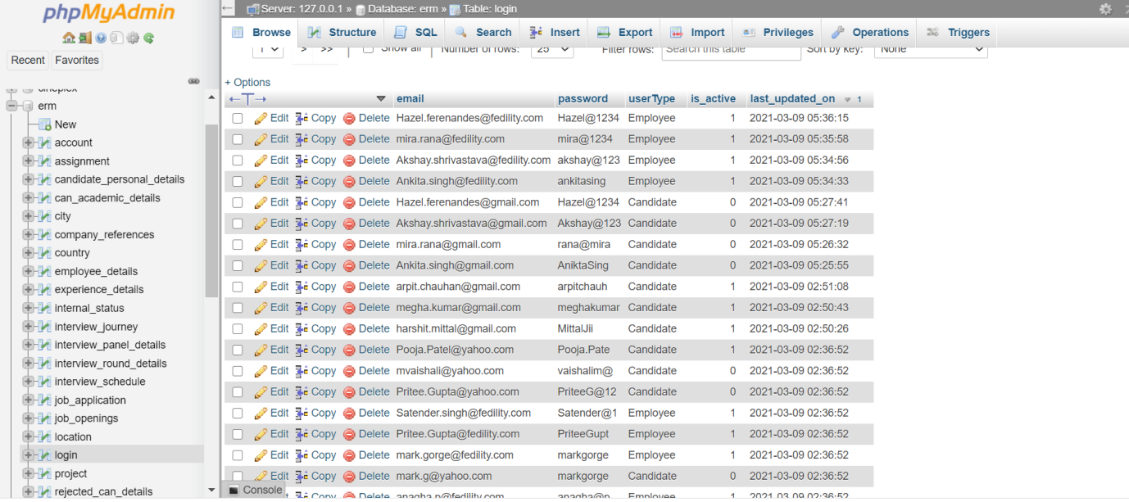

insert into internalstatus(status\_id,status,description) values (1, "Fresh Candidate", "Recently registered or the candidate who has never been interviewed will be given the status of Fresh Candidate")

INSERT INTO `internal\_status`(`status`, `description`) VALUES ("In-Pipe","This status indicates that the interview has been scheduled with the candidate")

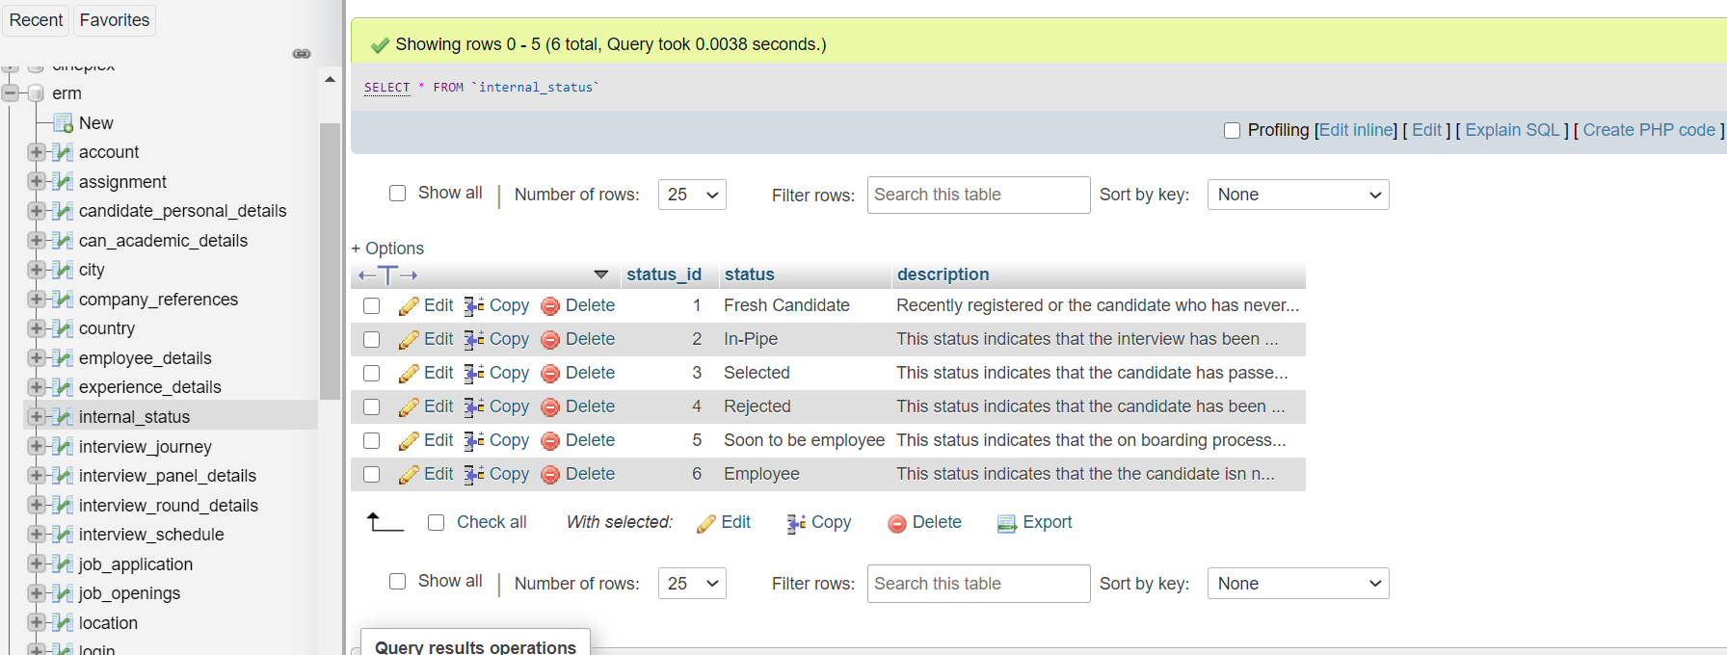

INSERT INTO candidate\_personal\_details(firstName, lastName, email, country\_code, contactNumber, permenent\_address, temp\_address, is\_address\_same,internalStatus, experience, resume) VALUES ("Tejashree","K","tejashree.t@gmail.com","+91",9408652319,"Sector36, Gurgaon","null",false,3.1,1,"D:\ERM\Resume\Tejashree.docx")

INSERT INTO candidate\_personal\_details(firstName, lastName, email, country\_code, contactNumber, permenent\_address, temp\_address, is\_address\_same,internalStatus, experience, resume) VALUES ("Anagha","P","anagha.p@fidelity.com","+91",9408652317,"Vasant Vihar, Delhi","Blueridge,Pune",false,"6+",6,"D:\ERM\Resume\Anagha P.docx")

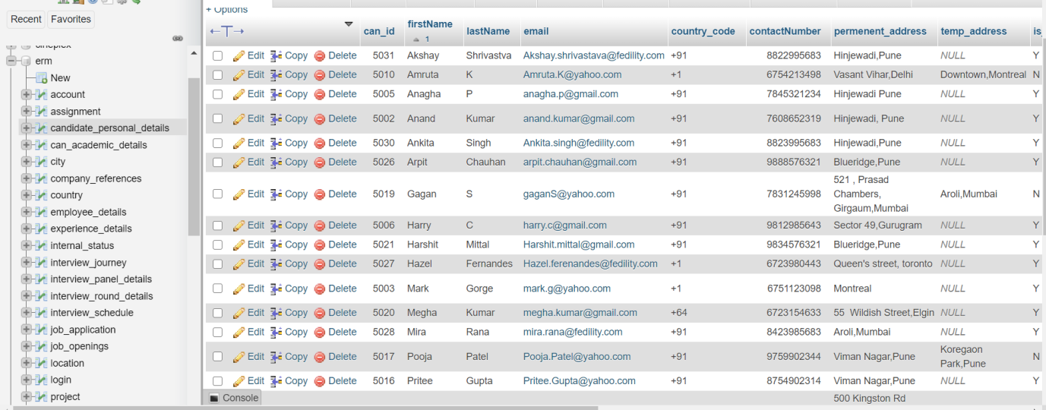

Insert into experience\_details(exp\_id,can\_id,company\_name,start\_date,end\_date) values (1,5001,”Cognizant India’,”2019-05-03”,”2021-02-28”)

INSERT INTO `experience\_details`(`can\_id`, `company\_name`, `start\_date`) VALUES (5002,"Globant India","2018-11-20")

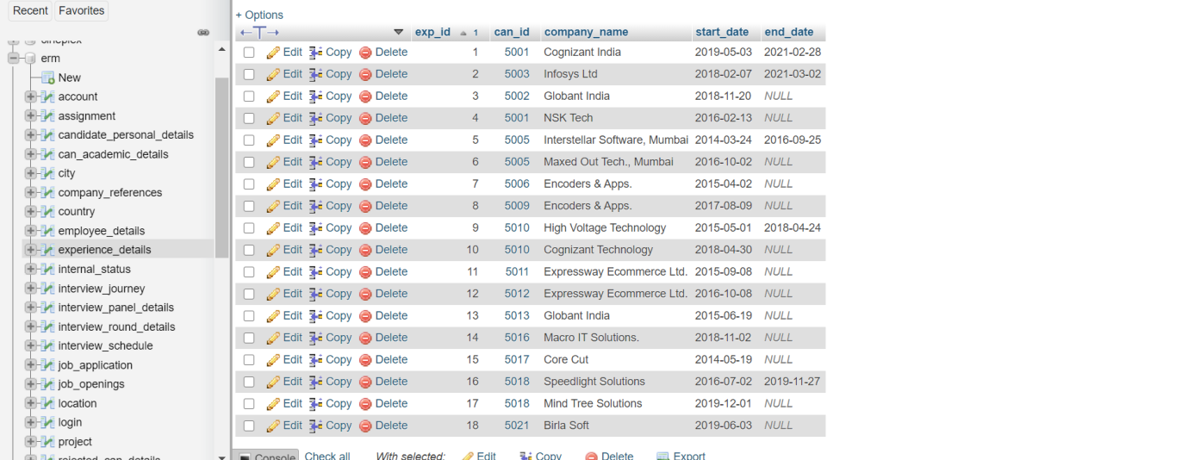

INSERT INTO work\_experience\_documents(doc\_id, exp\_id, releaving\_ltr, experience\_ltr) VALUES (1,1,"D:\\ERM\\Work Experience Document\\Tej\_experience\_ltr.docx",null)

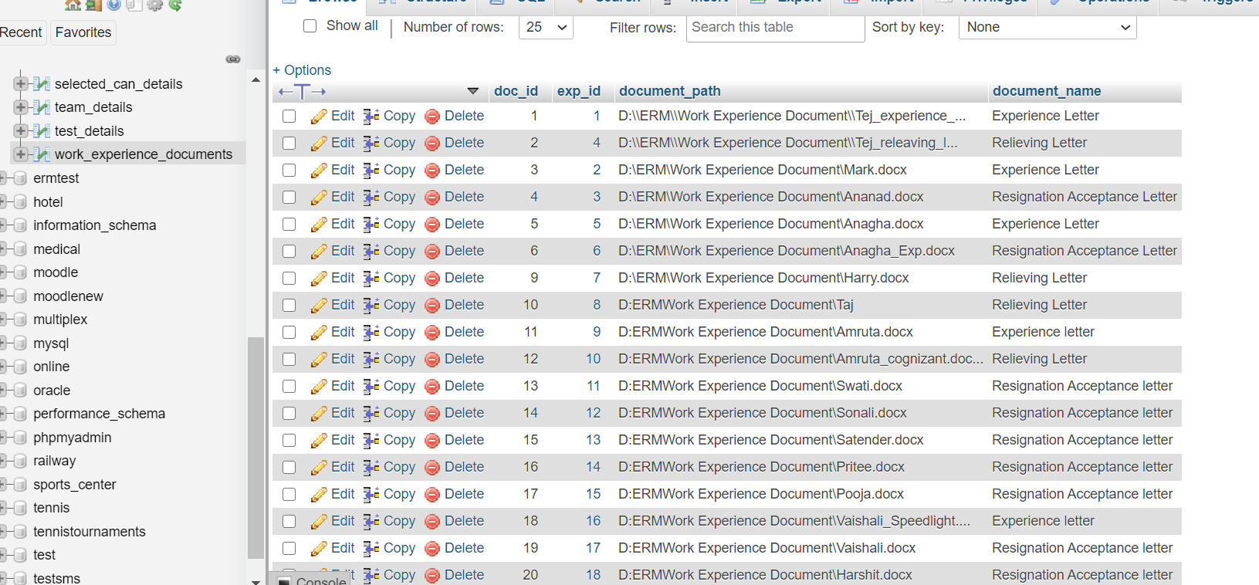

INSERT INTO `company\_references`(`reference\_id`, `exp\_id`, `referenceOne\_Fname`, `referenceOne\_Lname`, `referenceOne\_email`, `referenceOne\_countryCode`,`referenceOne\_contact`, `referenceOne\_designation`, `referenceOne\_relation`, `referenceTwo\_Fname`, `referenceTwo\_Lname`, `referenceTwo\_email`,`referenceTwo\_countryCode`, `referenceTwo\_contact`, `referenceTwo\_designation`, `referenceTwo\_relation` ) VALUES (1,1,"Mukesh","Agrawal","mukesh.agrawal@infosys.com","+91","9834762378","Project Manager","Project\_Manager","Atul","Rane","atul.rane@infosys.com","+91","7834567294","Java Developer","Team Lead")

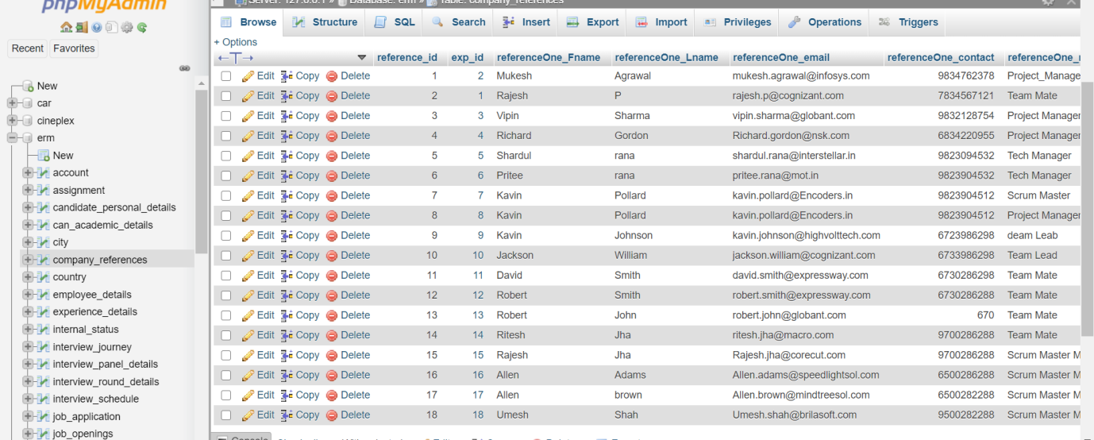

INSERT INTO `interview\_panel\_details`(`interviewer\_Name`, `department\_name`, `interviewer\_email`, `expertise`, `experience`, `role`) VALUES ("Satender Singh","Devops","satendet.singh@fedility.com","Jenkins","3+","Devops Engineer")

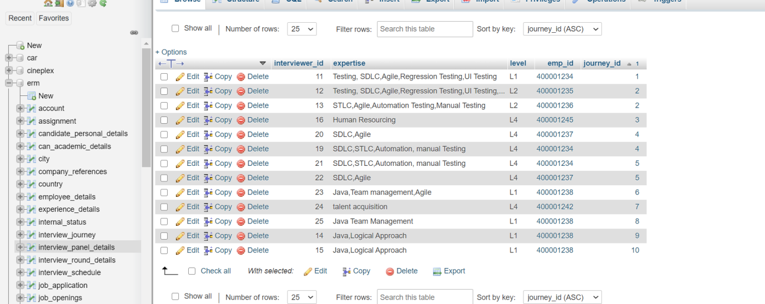

INSERT INTO `interview\_round\_details`(`round\_id`, `round\_name`, `description`, `priority`) VALUES (1,"Written Test","Round includes a written test with logical questions", "Round 1")

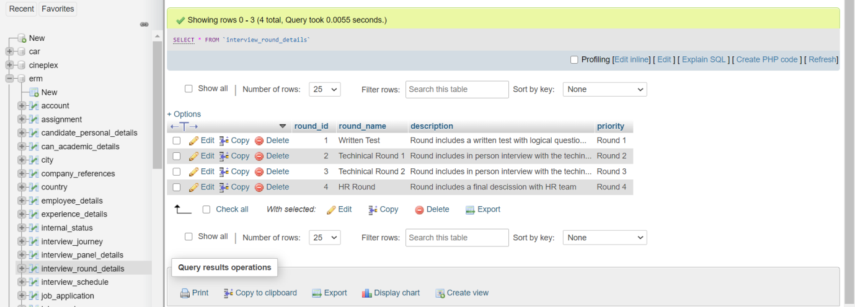

INSERT INTO `job\_application`(`can\_id`, `job\_id`,is\_valid) VALUES (5003,1002,true)

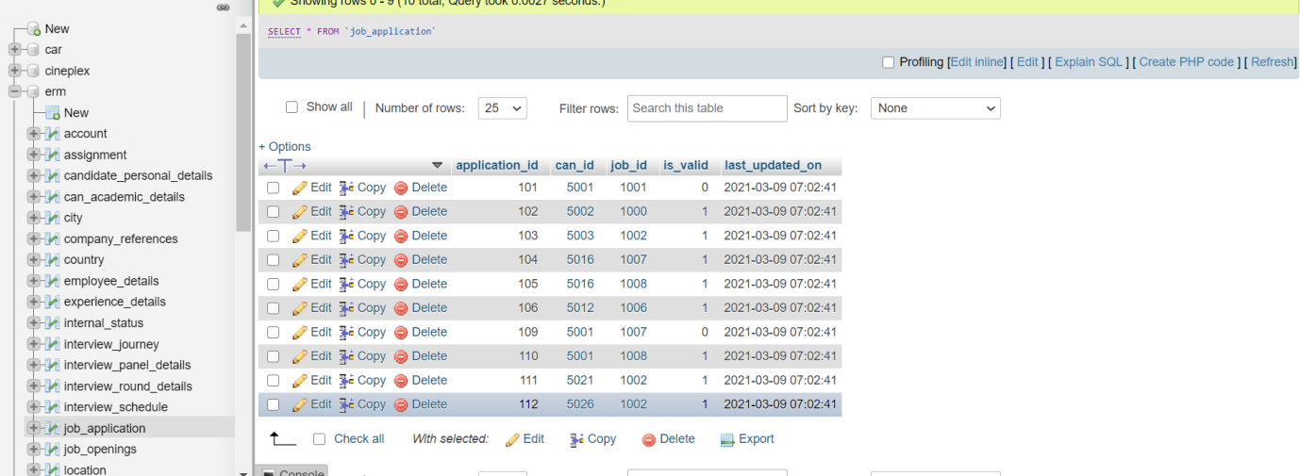

INSERT INTO `employee\_details`(`work\_email`, `can\_id`, `designation`, `salary PA`, `department`, `emp\_id`) VALUES ("anagha.p@fedility.com",5005,"Techinical Manager","10 LPA", "Quality Assurance",400001234)

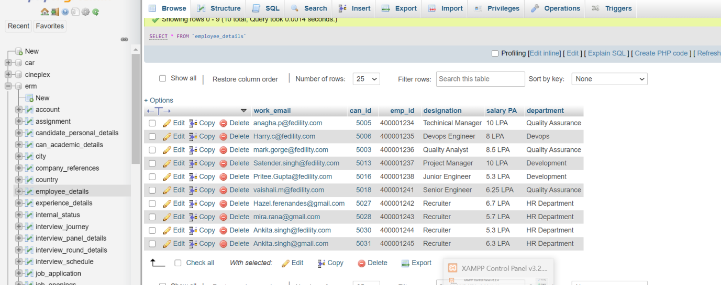

INSERT INTO interview\_schedule(`interview\_id`, `application\_id`, `interview\_date`, `time\_slot`, `time\_zone`, `poc\_id`, `interview\_type`) VALUES (11,101,"2021-03-15","10.00 AM - 3.00 PM", "IST", 400001235,"In-Person Interview")

INSERT INTO `interview\_schedule`(`application\_id`, `interview\_date`, `time\_slot`, `time\_zone`, `poc\_id`, `interview\_type`, `interview\_link`) VALUES (102,"2021-03-16","10.00 AM- 3.00 PM","IST","400001235","Online Test","https://www.fedility.com/onlineTest")

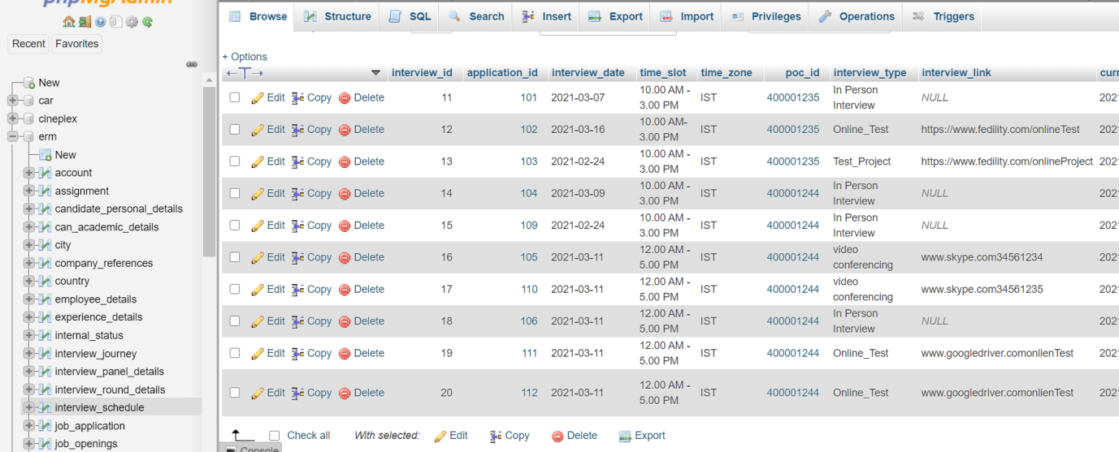

INSERT INTO `test\_details`( `project\_description`, `test\_detail\_doc`, `deadline`, `submiited\_date`, `interview\_id`) VALUES ("Automation Scription for e-commerce website","D:\\ERM\\Test Document\\Automation Test Projedct.docx","2021-03-22",13)

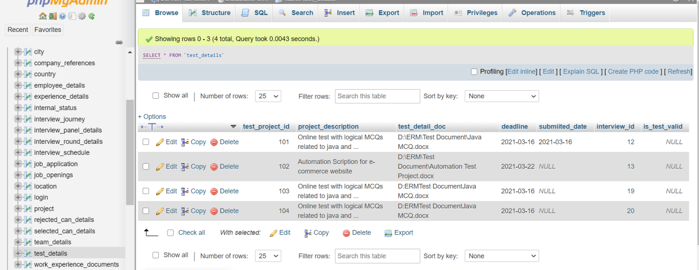

INSERT INTO `interview\_journey`(`journey\_id`, `interview\_id`, `round\_id`, `interviewer\_id`, `interview\_status`, `feedback`) VALUES (1,11,2,12,"Selected","Good problem solving skills")

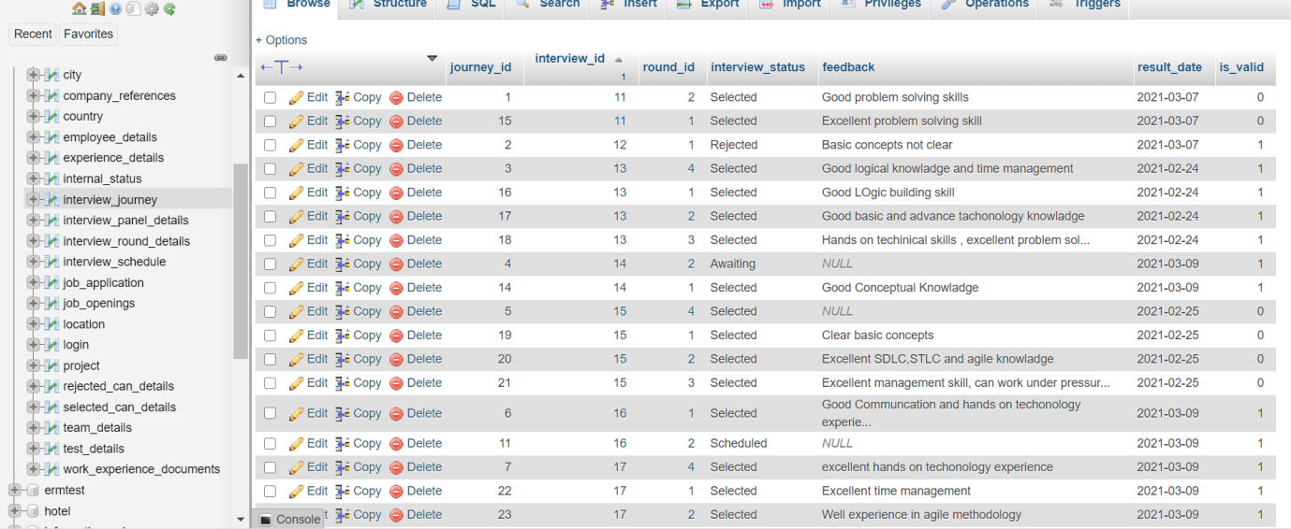

INSERT INTO rejected\_can\_details(rejected\_id, journey\_id, blocked\_till\_date) VALUES (1,2, Date\_Add(CURRENT\_DATE,INTERVAL 6 month))

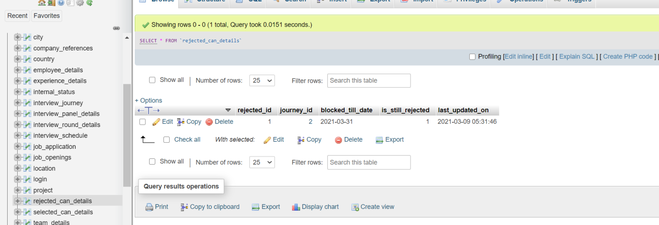

INSERT INTO selected\_can\_details(selected\_id, journey\_id, hire\_date, is\_offer\_accepted) VALUES (10,3,"2021-05-07","Y")

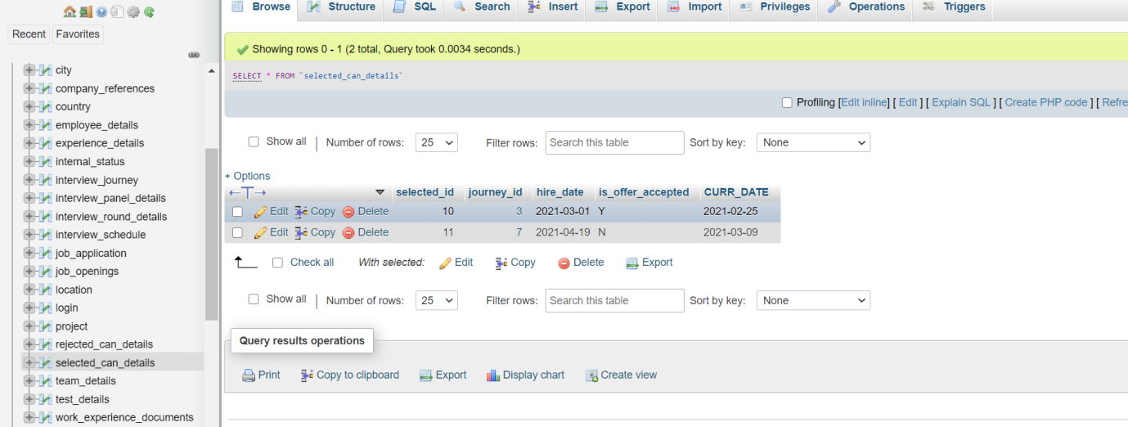

insert into account (account\_id,account\_name) values (8001,"Disney")

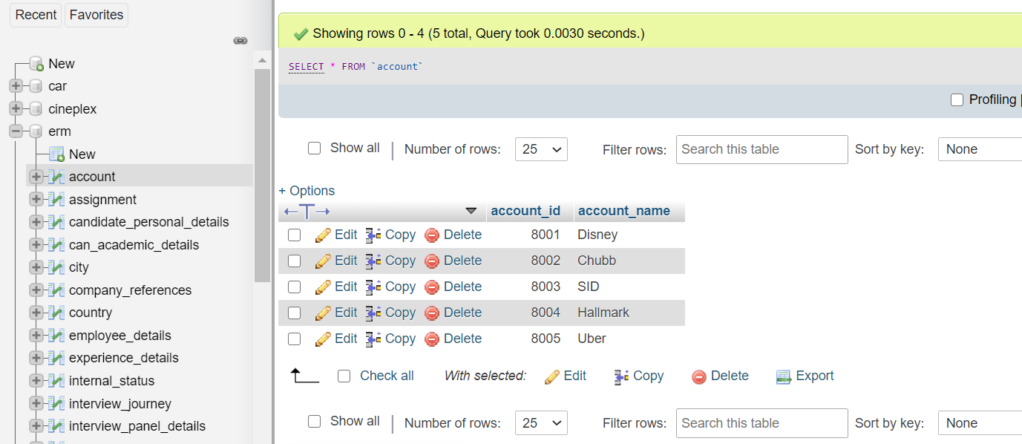

INSERT INTO `project`(`project\_id`, `project\_name`, `start\_date`, `end\_date`, `duration`, `account\_id`) VALUES (2001,"SID Dev","2019-02-12","2021-12-31",timestampdiff(month,"2019-02-12","2021-12-31"),8001)

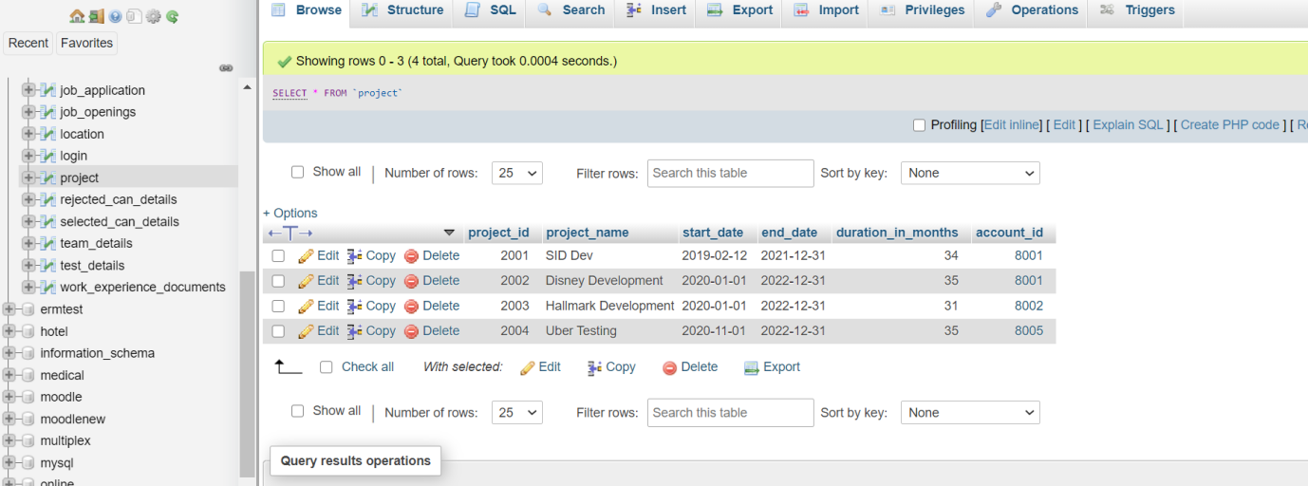

INSERT INTO `team\_details`(`team\_name`, `project\_id`) VALUES ("SID QA Team",2001)

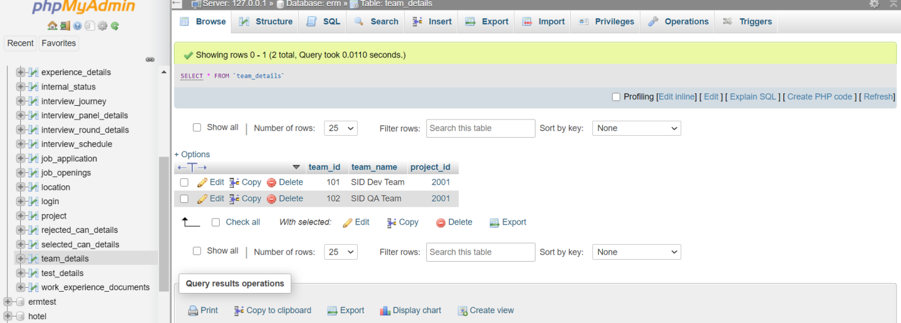

INSERT INTO `assignment`(`assignment\_id`, `emp\_id`, `reporting\_manager`, `team\_id`, `assignment\_start\_date`, `assignment\_end\_Date`) VALUES (1001,400001236,400001234,102,"2021-04-01","2022-04-01")

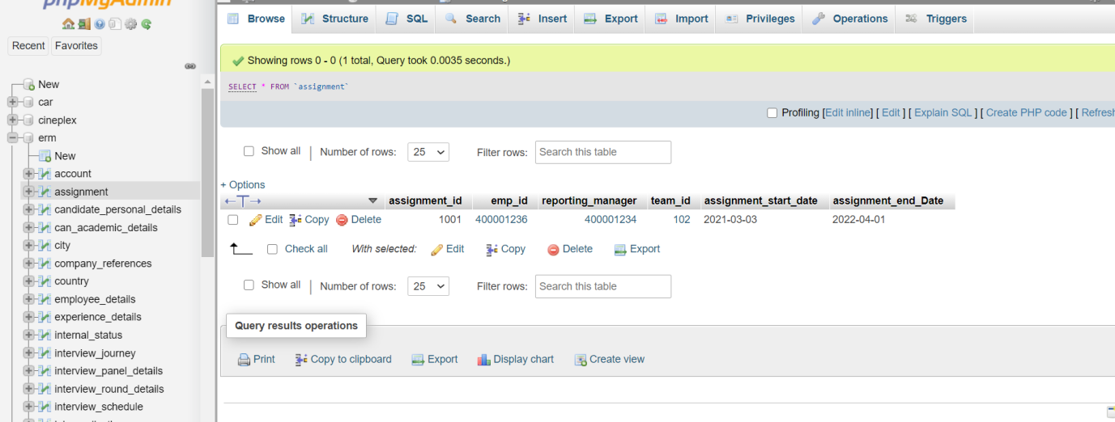

INSERT INTO can\_academic\_details(academic\_record\_id, can\_id, academics, specification, board\_university, passing\_year, gap, grades, academic\_doc\_name, academic\_doc\_path) VALUES (11,5001,"B.Tech","Compoter Science And Techonology","Shivaji University","2015","N","7.2 GPA","Degree","D:\\ERM\\Acadamic Document\\Tejashree.docx")

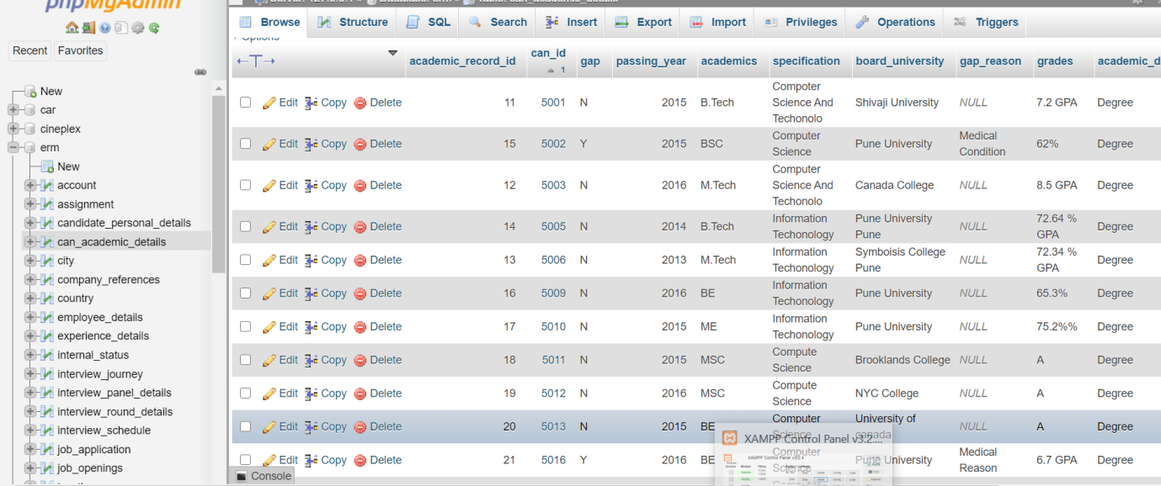

INSERT INTO `interview\_panel\_details`(`expertise`, `level`, `emp\_id`, `journey\_id`) VALUES ("STLC,Agile,Automation Testing,Manual Testing","L2",400001236,2)

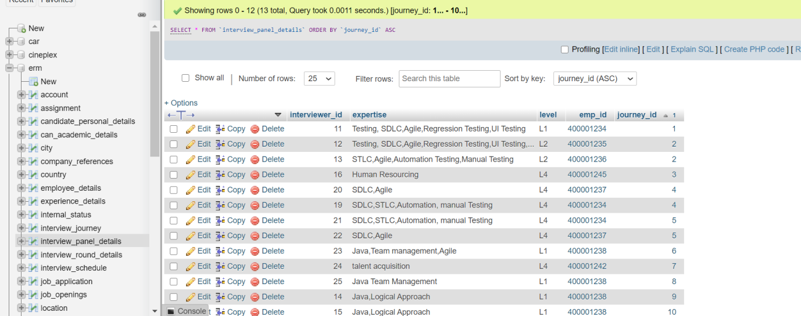

***Update queries***

Update candidate\_personal\_details set internalStatus = 6 where email [="Ankita.singh@fedility.com"](mailto:=\"Ankita.singh@fedility.com\")

UPDATE candidate\_personal\_details set internalStatus = 5 WHERE can\_id = 5001

***Delete queries***

update rejected\_can\_details set is\_still\_rejected = false where blocked\_till\_date < CURRENT\_DATE

update login set is\_active = false where email = "hazel.fernandes@gmail.com"

update job\_application set is\_valid = false where application\_id in (101,109)

update interview\_schedule set is\_valid = false where interview\_id in (11,15)

update job\_openings set is\_active = false where job\_id =1010

***Select queries***

1. **Display the job opening details which has more than one candidate application?**

select job\_openings.\*, count(job\_application.can\_id) as numberOfApplications from job\_application join job\_openings on job\_application.job\_id = job\_openings.job\_id group by(job\_application.job\_id) having numberOfApplications >1

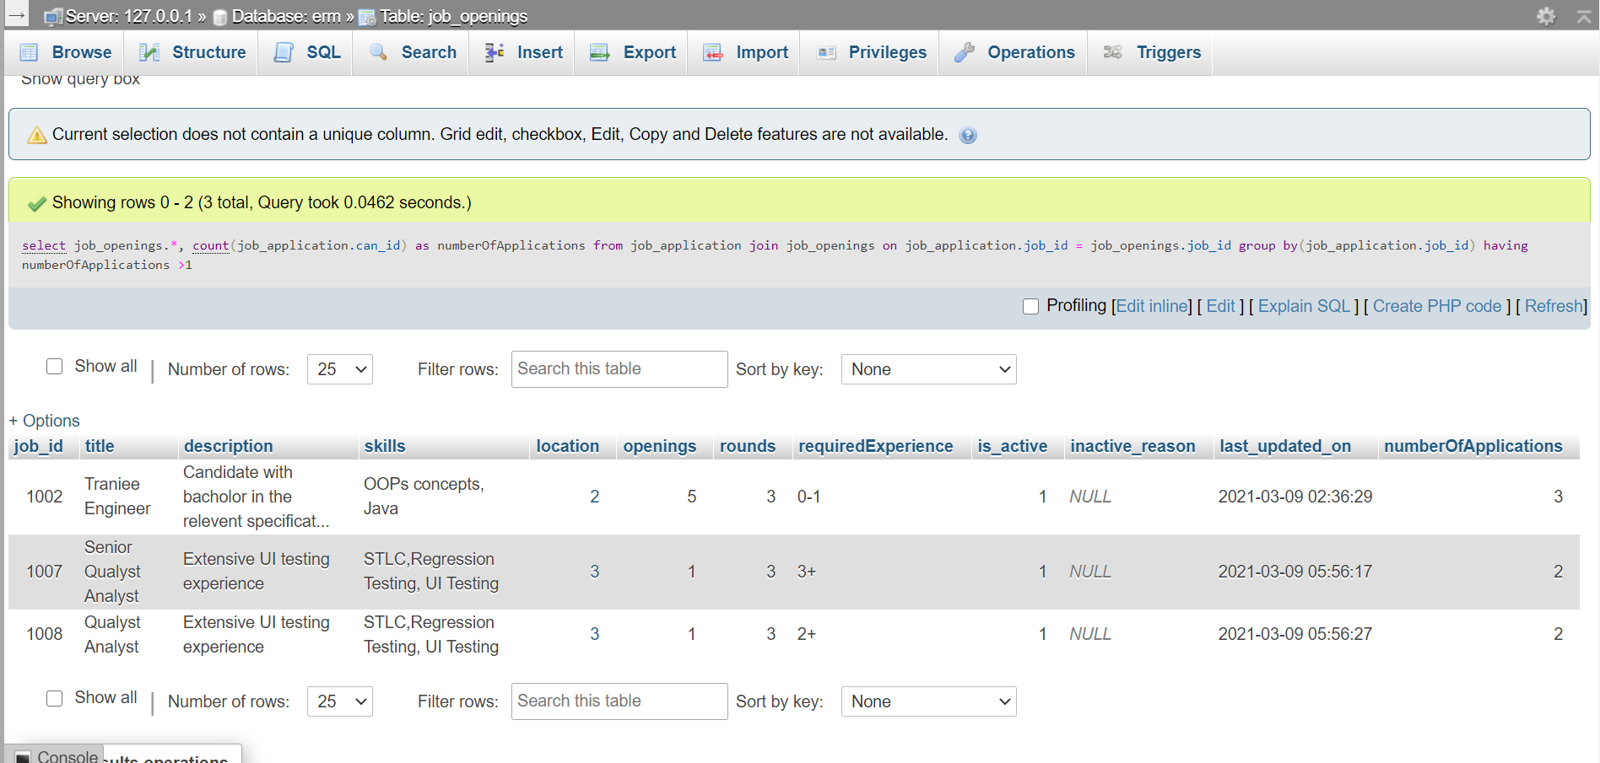

1. **Display the details of job which is now inactive**

SELECT \* FROM `job\_openings` WHERE is\_active= false

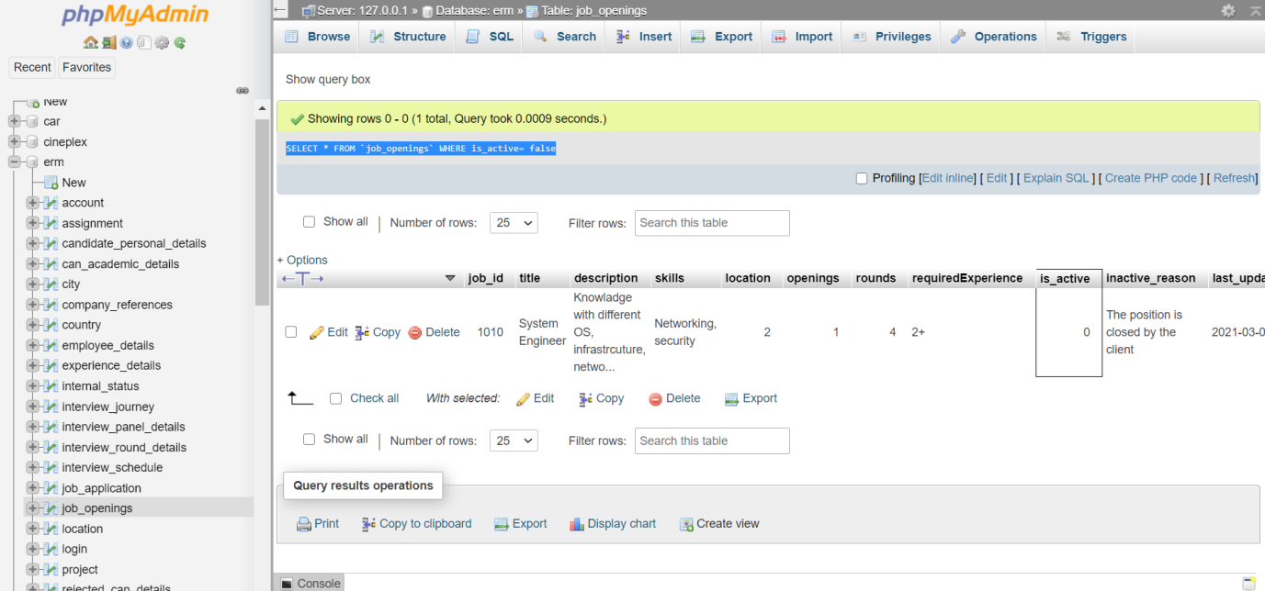

1. **Display the details of interview which has been canceled**

SELECT \* FROM `interview\_schedule` WHERE schedule\_status = "Canceled"

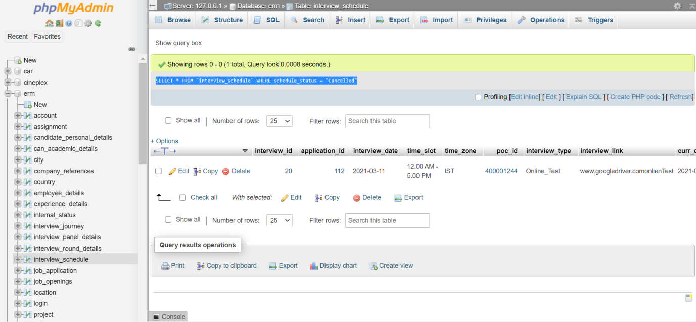

1. **Display the details of reporting manager of an employee**

select concat(candidate\_personal\_details.firstName,' ',candidate\_personal\_details.lastName) as manager ,employee\_details.work\_email,employee\_details.designation,

team\_details.team\_name,assignment.emp\_id from team\_details INNER join assignment on team\_details.team\_id= assignment.team\_id INNER join employee\_details on assignment.reporting\_manager = employee\_details.emp\_id INNER join candidate\_personal\_details on employee\_details.can\_id=candidate\_personal\_details.can\_id

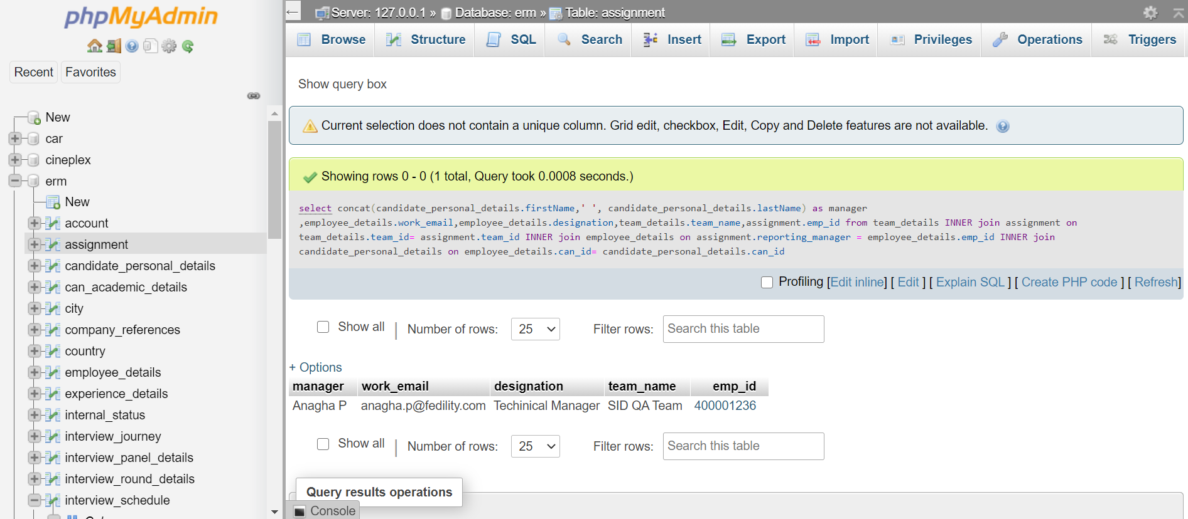

1. **Get the details of candidate,interviewer emp\_id and interview\_email with interview slot whose interview is scheduled for today.**

select candidate\_personal\_details.firstName,candidate\_personal\_details.lastName,

candidate\_personal\_details.email,candidate\_personal\_details.contactNumber, employee\_details.emp\_id as interviewer\_id,employee\_details.work\_email as

interviewer\_email, interview\_schedule.interview\_date,interview\_schedule.time\_slot

from candidate\_personal\_details INNER JOIN job\_application on

candidate\_personal\_details.can\_id =job\_application.can\_id INNER join

interview\_schedule on job\_application.application\_id = interview\_schedule.application\_id INNER JOIN interview\_journey on interview\_schedule.interview\_id = interview\_journey.interview\_id INNER JOIN interview\_panel\_details on interview\_journey.journey\_id = interview\_panel\_details.journey\_id INNER join employee\_details on interview\_panel\_details.emp\_id = employee\_details.emp\_id where interview\_schedule.interview\_date = CURRENT\_DATE

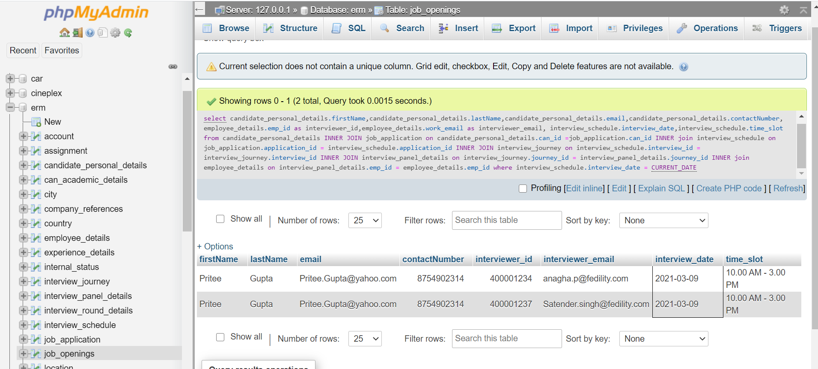

1. **Display the details of the interviewers who are in the same panel**

select \* from interview\_panel\_details emp1 , interview\_panel\_details emp2 where emp1.emp\_id <> emp2.emp\_id and emp1.journey\_id=emp2.journey\_id and emp1.emp\_id < emp2.emp\_id

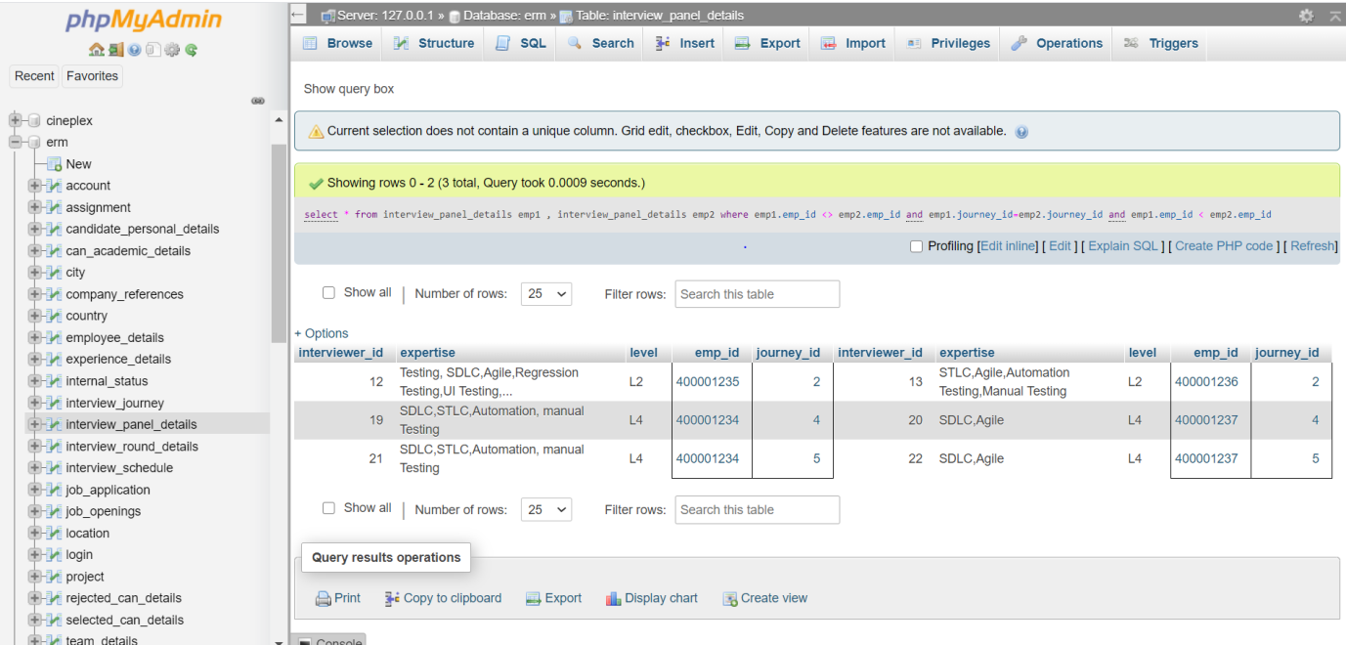

1. **Display the details of candidate whose candidate login details are no longer valid**

select \* from candidate\_personal\_details INNER join login on candidate\_personal\_details.email = login.email where login.is\_active = false

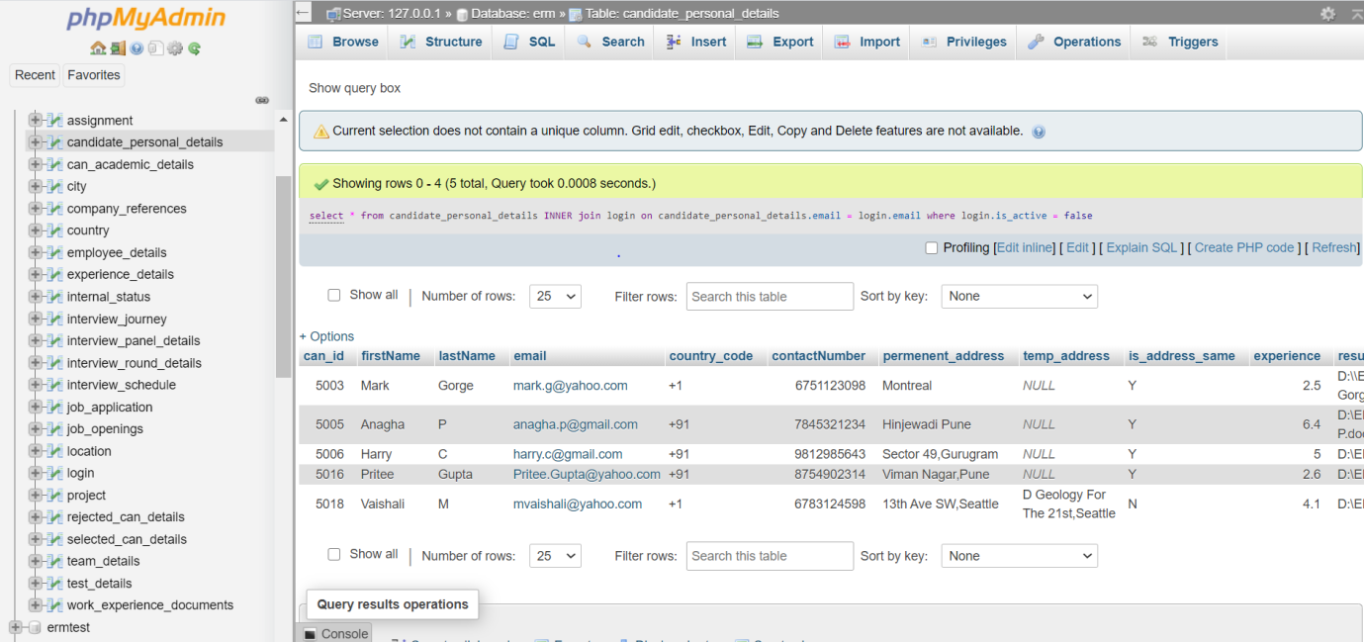

1. **Get Academic details of all candidate**

select concat(candidate\_personal\_details.firstName,' ',candidate\_personal\_details.lastName) as Name,candidate\_personal\_details.email,candidate\_personal\_details.contactNumber,

candidate\_personal\_details.highest\_education, can\_academic\_details.\* from candidate\_personal\_details INNER join can\_academic\_details on candidate\_personal\_details.can\_id= can\_academic\_details.can\_id

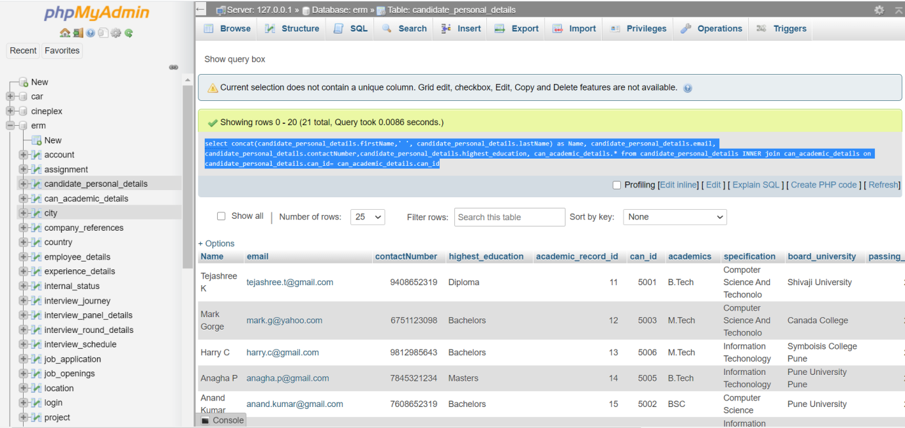

1. **Display details of candidate applied for more than 1 location**

select distinct(candidate\_personal\_details.can\_id),count(country.country\_abbrivation) as locationCount, concat(candidate\_personal\_details.firstName,' ',

candidate\_personal\_details.lastName) as Name, candidate\_personal\_details.email,

candidate\_personal\_details.contactNumber from candidate\_personal\_details INNER join job\_application on candidate\_personal\_details.can\_id=job\_application.can\_id INNER join job\_openings on job\_application.job\_id=job\_openings.job\_id INNER join location on job\_openings.location = location.id INNER join city on location.city\_id=city.id INNER join country on city.country\_abbrivation=country.country\_abbrivation having locationCount>1

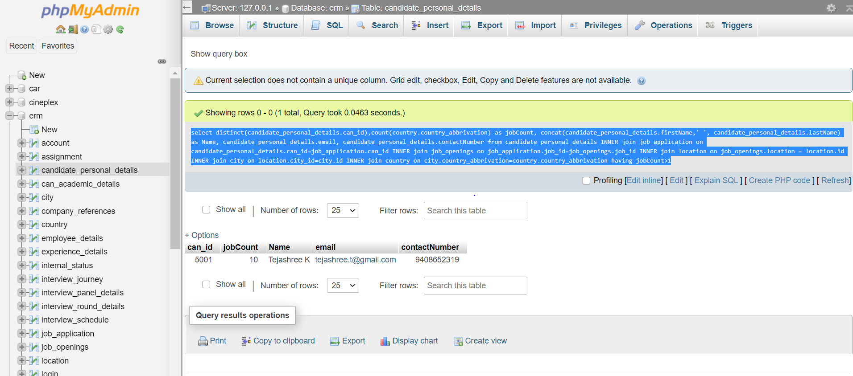

1. **Get the details of candidates who have applied for more than 1 job**

select candidate\_personal\_details.firstName,candidate\_personal\_details.lastName,

candidate\_personal\_details.email,candidate\_personal\_details.contactNumber, count(job\_application.job\_id) as numberOfAppliedJobs from candidate\_personal\_details INNER join job\_application on candidate\_personal\_details.can\_id=job\_application.can\_id GROUP by job\_application.can\_id having numberOfAppliedJobs> 1

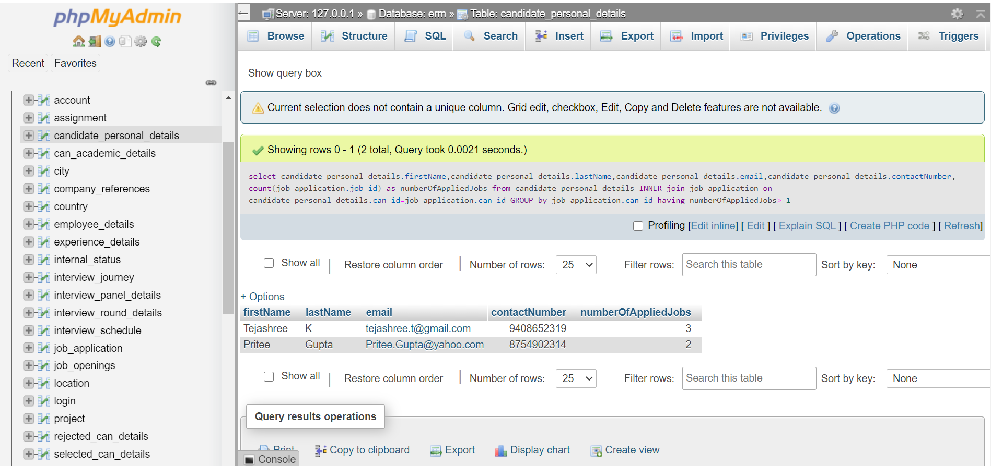

1. **Get the details of candidate and the blocked till date who is currently blocked from applying to any job opening?**

select candidate\_personal\_details.firstName,candidate\_personal\_details.lastName,

candidate\_personal\_details.email,candidate\_personal\_details.contactNumber, rejected\_can\_details.blocked\_till\_date from candidate\_personal\_details INNER JOIN job\_application on candidate\_personal\_details.can\_id =job\_application.can\_id INNER join interview\_schedule on job\_application.application\_id = interview\_schedule.application\_id INNER JOIN interview\_journey on interview\_schedule.interview\_id= interview\_journey.interview\_id INNER join rejected\_can\_details on interview\_journey.journey\_id = rejected\_can\_details.journey\_id where rejected\_can\_details.blocked\_till\_date > CURRENT\_DATE

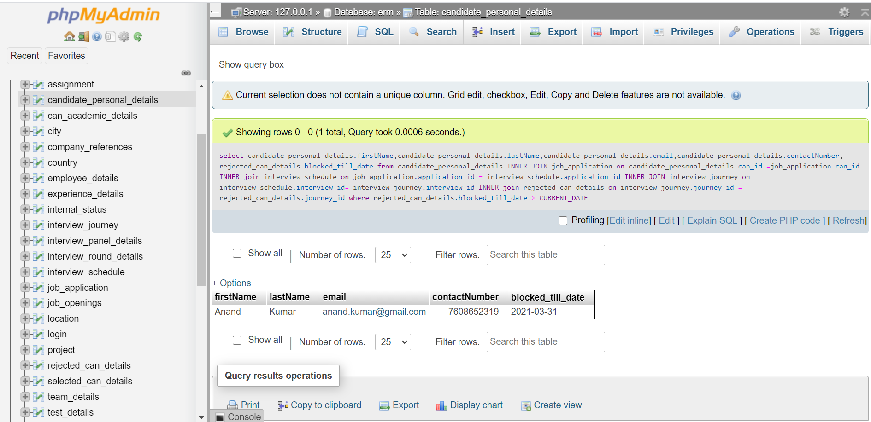

1. **Displayed details of candidate whose currently undergoing the interview process. (i.e interviews are going on )**

select candidate\_personal\_details.firstName,candidate\_personal\_details.lastName,

candidate\_personal\_details.email,candidate\_personal\_details.contactNumber, internal\_status.status from candidate\_personal\_details INNER join internal\_status on candidate\_personal\_details.internalStatus= internal\_status.status\_id where candidate\_personal\_details.internalStatus = (select status\_id from internal\_status where status = "In-Pipe")

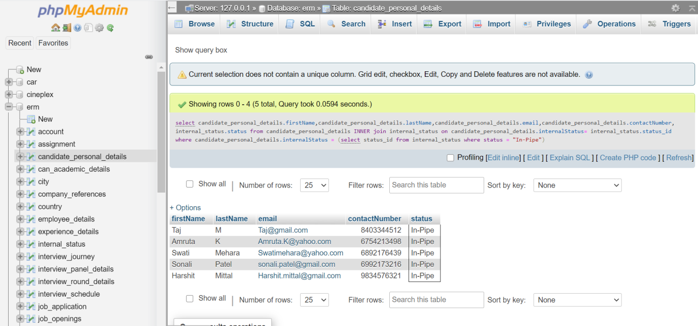

1. **Display candidate details and interview date which are scheduled for this month**

select candidate\_personal\_details.firstName,candidate\_personal\_details.lastName,

candidate\_personal\_details.email,candidate\_personal\_details.contactNumber, interview\_schedule.interview\_date,interview\_schedule.time\_slot from candidate\_personal\_details INNER JOIN job\_application on candidate\_personal\_details.can\_id =job\_application.can\_id INNER join interview\_schedule on job\_application.application\_id = interview\_schedule.application\_id where YEAR(interview\_schedule.interview\_date) = YEAR(CURRENT\_DATE()) AND MONTH(interview\_schedule.interview\_date) = MONTH(CURRENT\_DATE()) AND candidate\_personal\_details.internalStatus != (select status\_id from internal\_status where status = "Rejected")

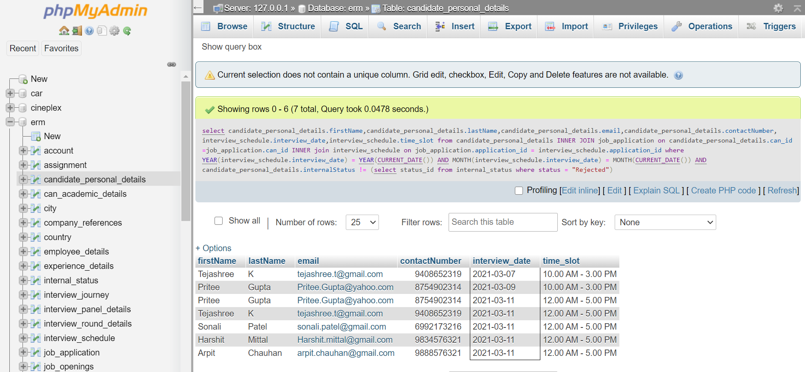

1. **Display the details of candidate who are joining the organization in next month**

select candidate\_personal\_details.firstName,candidate\_personal\_details.lastName, candidate\_personal\_details.email,candidate\_personal\_details.contactNumber,selected\_can\_details.hire\_date as joining\_date from candidate\_personal\_details INNER JOIN job\_application on candidate\_personal\_details.can\_id =job\_application.can\_id INNER join interview\_schedule on job\_application.application\_id = interview\_schedule.application\_id INNER join interview\_journey on interview\_schedule.interview\_id=interview\_journey.interview\_id INNER join selected\_can\_details on interview\_journey.journey\_id = selected\_can\_details.journey\_id where selected\_can\_details.hire\_date >=(AddDate(CURRENT\_DATE, interval 1 month))

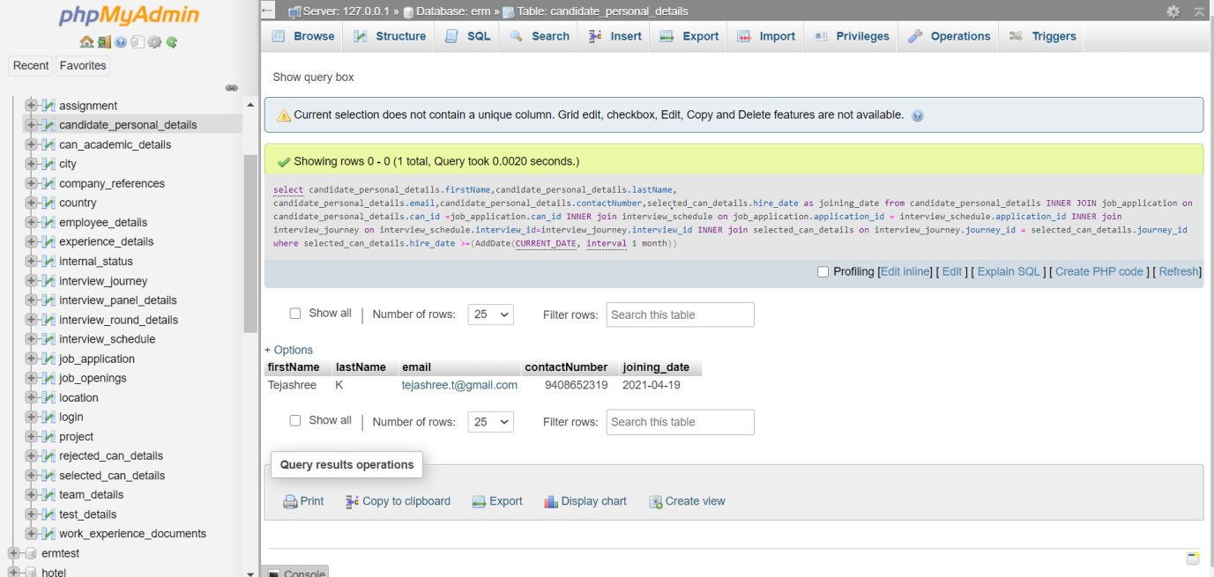

1. **Show the details of upcoming interview and candidate for current month**

select candidate\_personal\_details.firstName,candidate\_personal\_details.lastName,

candidate\_personal\_details.email,candidate\_personal\_details.contactNumber, employee\_details.emp\_id as interviewer\_id,employee\_details.work\_email as interviewer\_email, interview\_schedule.interview\_date,interview\_schedule.time\_slot from candidate\_personal\_details INNER JOIN job\_application on candidate\_personal\_details.can\_id =job\_application.can\_id INNER join interview\_schedule on job\_application.application\_id = interview\_schedule.application\_id INNER JOIN interview\_journey on interview\_schedule.interview\_id = interview\_journey.interview\_id INNER JOIN interview\_panel\_details on interview\_journey.journey\_id = interview\_panel\_details.journey\_id INNER join employee\_details on interview\_panel\_details.emp\_id = employee\_details.emp\_id where YEAR(interview\_schedule.interview\_date) = YEAR(CURRENT\_DATE()) AND MONTH(interview\_schedule.interview\_date) = MONTH(CURRENT\_DATE()) AND Date(interview\_schedule.interview\_date) > Date(CURRENT\_DATE()) and

candidate\_personal\_details.internalStatus != (select status\_id from internal\_status where status = "Rejected")

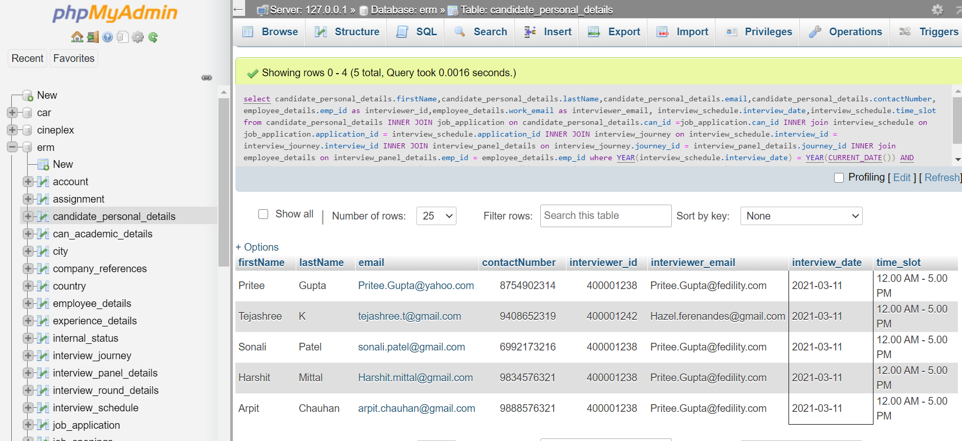

1. **Display the interview journey of the selected candidate (All rounds cleared)**

select candidate\_personal\_details.firstName,candidate\_personal\_details.lastName,

candidate\_personal\_details.email,candidate\_personal\_details.contactNumber ,interview\_sc hedule.interview\_date,interview\_schedule.time\_slot,interview\_journey.round\_id,interview\_ journey.interview\_status,interview\_journey.feedback from candidate\_personal\_details INNER JOIN job\_application on candidate\_personal\_details.can\_id =job\_application.can\_id INNER join interview\_schedule on job\_application.application\_id = interview\_schedule.application\_id INNER JOIN interview\_journey on interview\_schedule.interview\_id = interview\_journey.interview\_id where candidate\_personal\_details.internalStatus = (select status\_id from internal\_status where status = "Soon to be employee") and job\_application.is\_valid = true order by interview\_journey.round\_id desc

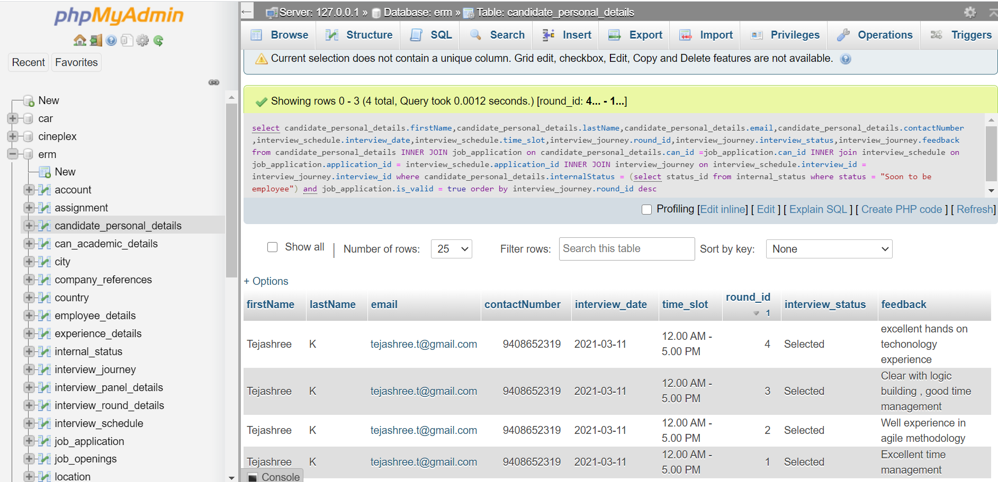

1. **Details of candidate who are being interviewed by more than one interviewer for the same round**

select DISTINCT(job\_application.job\_id), CONCAT(candidate.firstName, ' ', candidate.lastName)as candidate,candidate.email,candidate.contactNumber,

interview\_schedule.interview\_date,interview\_schedule.time\_slot, count(interview\_panel\_details.emp\_id) as numberOfInterviewers from job\_application INNER JOIN candidate\_personal\_details candidate on candidate.can\_id= job\_application.can\_id INNER JOIN interview\_schedule on job\_application.application\_id = interview\_schedule.application\_id INNER JOIN interview\_journey on interview\_schedule.interview\_id= interview\_journey.interview\_id inner join interview\_panel\_details on interview\_journey.journey\_id = interview\_panel\_details.journey\_id group by interview\_panel\_details.journey\_id having numberOfINterviewers >1

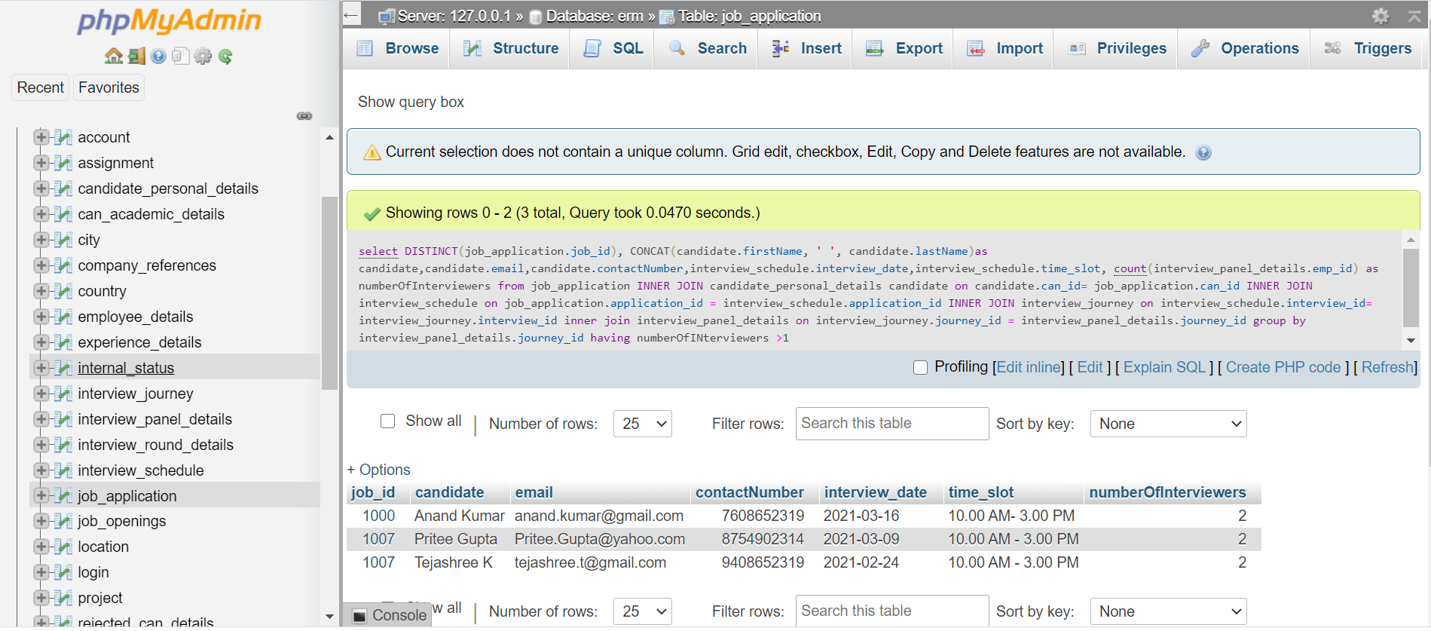

1. **Get the point of contact details for today’s interview**

select concat(candidate\_personal\_details.firstName,' ',candidate\_personal\_details.lastName) as name, candidate\_personal\_details.contactNumber,employee\_details.work\_email from interview\_schedule INNER JOIN employee\_details on interview\_schedule.poc\_id=employee\_details.emp\_id INNER JOIN candidate\_personal\_details on employee\_details.can\_id=candidate\_personal\_details.can\_id where interview\_schedule.interview\_date = CURRENT\_DATE

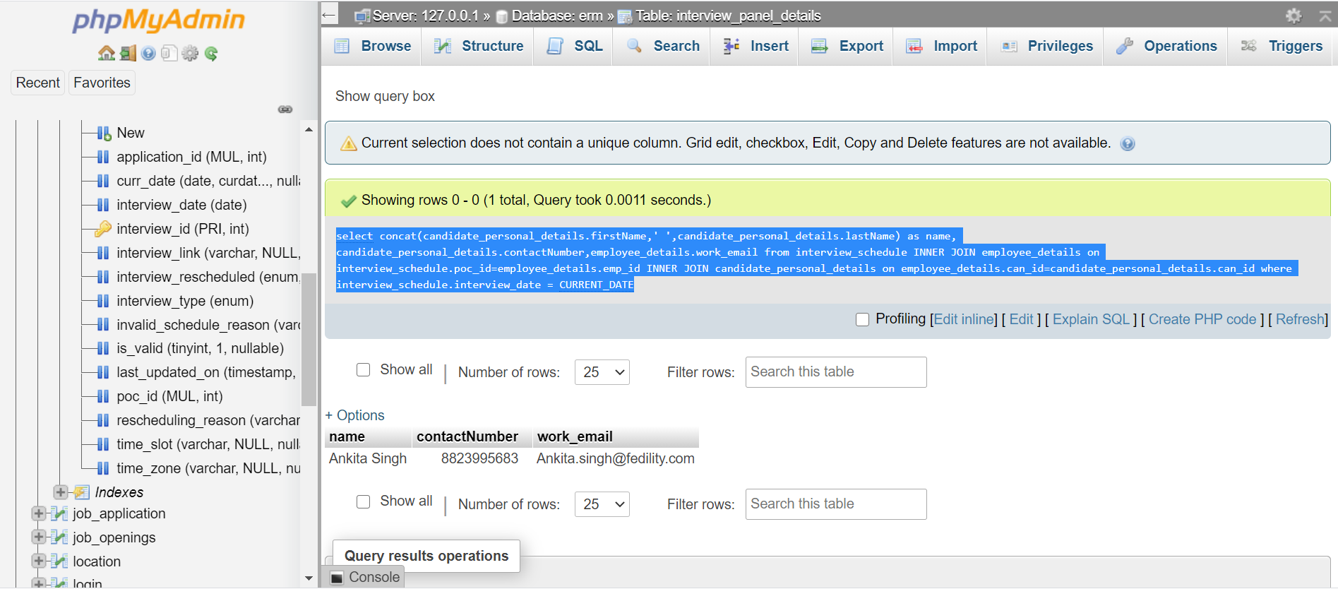

1. **Display the details of candidate who have relevant skills,experience and are in the same location.**

select concat(candidate\_personal\_details.firstName,' ',candidate\_personal\_details.lastName) as can\_name, candidate\_personal\_details.email,candidate\_personal\_details.contactNumber,candidate\_personal\_details.experience,job\_openings.job\_id,job\_openings.title,job\_openings.description,candidate\_personal\_details.key\_skills as can\_skills, job\_openings.skills as required\_skills from candidate\_personal\_details INNER join job\_application on job\_application.can\_id = candidate\_personal\_details.can\_id INNER join job\_openings on job\_openings.job\_id= job\_application.job\_id where candidate\_personal\_details.experience >= cast(job\_openings.requiredExperience as int) and candidate\_personal\_details.country in (select city.country\_abbrivation from city INNER join location on city.id= location.city\_id INNER join job\_openings on location.id=job\_openings.location ) and (select INSTR(candidate\_personal\_details.key\_skills, "Agile") as required\_skill)

**Project Links**

<https://drive.google.com/drive/folders/1n7Uot_iIUfnq1-kMcARBiwZvCXK_lGjG?usp=sharing>

**Folder Includes:**

* The exported database in .sql format
* The ER diagram
* The folder containing all employee/candidate documents.

Bibliography

* [www.Tutorialspoint.com](http://www.Tutorialspoint.com)
* [www.JavaTPoint.com](http://www.JavaTPoint.com)
* [www.geeksforgeeks.com](http://www.geeksforgeeks.com)
* [www.stackoverflow.com](http://www.stackoverflow.com)
* <https://forums.mysql.com/>